EASTERN REGION GUIDEBOOK

TREE SEED PROGRAM
November 4, 2019 Draft
Contents
Objectives of Tree Seed Program 3
Responsibility for Program 3
Regional Office 3
National Forest 4
Toumey Nursery 4
Definitions 5
Choosing the species 5
Genetic variation 5
Past and future changes in climate 6
Old tree seed collection zones and seed use guidelines 7
New considerations in seed source selection 9
New considerations in seed use 9
Matching seed source to future climate 10
Seed Acquisition 12
Assessing Seed Needs 12
10 Year Seed Plans 12
Know the Origin of All Seed 13
Types of Collection Areas for Reforestation and Restoration 14
General Collections 14
Selected Stands 15
Seed Production Areas 15
Seed Orchards 16
Funding to Collect Seed for Reforestation and Restoration 16
Working Capital Funds (WCF) 16
Knutson-Vandenberg Funds (KV) 17
Reforestation Trust Funds (RTRT) 17
National Forest Vegetation and Watershed Funds (NFVW) 17
Good Neighbor Authority (GNA) and Stewardship Funds 17
Stewardship 17
Preparing for Cone and Seed Collection 17
Methods of Cone and Seed Collection 19
From the Ground 19
Using a Pole Pruner 19
After Felling 19
Firearms 20
Climbing 20
Mechanical Lift 20
Maintain the Identify of Cones and Seed 20
Care of Cones and Seed After Collection 21
Seed Collections for Species Conservation 22
Recommendations for Region 9 Forests 23
Allegheny National Forest 24
Chequamegon National Forest 24
Chippewa National Forest 27
Finger Lakes National Forest 27
Green Mountain National Forest 30
Hiawatha National Forest 30
Hoosier National Forest 30
Huron National Forest 35
Manistee National Forest 35
Mark Twain National Forest 35
Midewin National Tallgrass Prairie 39
Monongahela National Forest 39
Nicolet National Forest 44
Ottawa National Forest 44
Shawnee National Forest 44
Superior National Forest 48
Wayne National Forest 48
White Mountain National Forest 52
References 56

The success of artificial reforestation and restoration depends on having enough high quality seed of the right source when it is needed. Having the right seed when you need it requires a well planned and executed seed program. This document describes the components of the Region 9 Tree Seed Program. This includes how to assess seed needs, how to obtain seed, how to pay for seed, and how to select an appropriate seedlot.
The Region 9 Supplement to the Seed Chapter of the Silviculture Handbook was last issued in 2006. It is now becoming obsolete as climate change accelerates. This document will provide guidelines to replace that document. It differs from the 2006 Handbook Supplement by allowing for and encouraging assisted migration in response to climate change.

Objectives of Tree Seed Program

The objectives of the Region 9 Seed Program are to:
- Supply seed that is adequate to support reforestation and restoration, including considerations for assisted migration.
- Supply seed that germinates and stores well.
- Supply seed that is genetically diverse.
- Supply seed of the species that are needed to meet management objectives.
- Supply seed that is adapted to the environment where it is planted, both at the time of planting and in the future.
- Conserve time and money by acquiring seed efficiently and not acquiring more than is needed.
- Preserve samples of seed of tree species that are threatened by highly destructive insects and diseases

Responsibility for Program

Many people have important roles to play if a Tree Seed Program is to be successful. This section will describe how these different roles fit together.

Regional Office

The Regional Geneticist should:
- Establish and update guidelines for determining what sources of tree seed are appropriate for each forest and authorizing exceptions to those guidelines when appropriate.
- Establish guidelines to manage the genetic diversity and maintain the viability of tree species.
- Assist or advise foresters, botanists and the manager of the J.W. Toumey Nursery on seed-related issues.
- Operate the Oconto River Seed Orchard to provide a portion of the seed needed by national forests in the northern Great Lakes states.
- Collect seed from the Oconto River Seed Orchard to meet recognized seed needs.
- Plant orchard blocks at the Oconto River Seed Orchard that anticipate future needs for seed on national forests in the northern Great Lakes states.
- Work with the manager of the J.W. Toumey Nursery and forests to estimate seed needs.

National Forest

Forest Silviculturist should:
- Determine which tree species should be planted on particular sites when artificial regeneration is required.
- Review the guidelines for seed source and choose an appropriate source of seed for each species that will be planted on each site with respect to the Forest Plan.
- Estimate the tree seed needs for the next 10 years and the seedling needs for the next 4 years. These should be submitted to the Manager of the J.W. Toumey Nursery when requested.
- Ensure the Forest is prepared to pay for costs that are incurred for seed that has been removed from the Regional Seed Cache to grow seedlings ordered by the Forest regardless of whether the seedlings are purchased or planted.
- Submit requests for Working Capital Funds (WCF) to collect cones or tree seed for the Forest to the manager of the J.W. Toumey Nursery.
- Acquire cones or tree seed from sources that are appropriate for the Forest and transport them to a seed cleaning facility, seed storage facility or the appropriate nursery.
- Order seedlings grown from appropriate seedlots from the J.W. Toumey Nursery or other nurseries if outside the northern Great Lakes states.
- Maintain records of which seedlots were used to reforest stands on the forest.

Toumey Nursery

The Manager of the J.W Toumey Nursery should:
- Operate the J.W. Toumey Nursery and the Regional Seed Cache.
- Work with the forest silviculturists and the regional geneticist to review seed needs, identify seed that should be collected, and notify forests and the Oconto River Seed Orchard of needs.
- Maintain a list of seed in storage and make it available to forests and the regional geneticist.
- Review requests for seed from forests and authorize the use of WCF funds to collect seed when appropriate.
- Clean seed collected by the forests or the Oconto River Seed Orchard and properly store it.
- Determine the price of seed stored in the Regional Seed Cache.
- Review requests for seedlings from the forests and select the appropriate seed lot to fill each Forest’s order in consultation with the Forest Silviculturists and the Regional Geneticist.
- Dispose of seed that is not needed or has poor germination.

Definitions

Assisted migration – Human-assisted movement of species or populations as a management response to climate change.
Cleaning (of seed) – Processing seed that has been collected to remove debris, seed of other species or poor quality seed.
Seed cache – A collection of seed maintained as a seed supply for nursery production.
Seed collection zone – A geographic area from which seed has been collected that is stored and used under that identity.
Seedlot – a general term that simply means a batch of seed that is stored or managed as a unit.
Seed orchard – a specialized plantation where trees of superior phenotype or genotype are managed intensively for production and collection of tree seed.
Seed production area – A stand or plantation that is managed extensively for production and collection of tree seed.
Seed use guideline (also known as Seed movement guideline) – Instructions that guide where a seed source can be planted.

Choosing the species

The first step of regenerating or reforesting a site is choosing the species. Tree species differ in their tolerance to site factors and climate and it is important to match the species to the site. A certified silviculturist should be consulted to determine which species are best suited for a particular site and management objectives.
In the past it made sense to assume that species that had done well on a site in the past would be ones that would continue to do well on the site in the future. As climate changes this will not always be true. Changes in climate are expected to make sites more suited for some species and less suited for others. The Climate Change Tree Atlas (a website tool developed by the Northern Research Station of USDA Forest Service ) can help in determining which tree species will be suited for a particular national forest in the future.

Genetic variation

Just as some species of trees can tolerate certain site conditions or climates better than other species, there can also be differences within species. There can be substantial differences within species for a wide array of traits related to site adaptation including bud burst, leaf fall, cold hardiness, drought hardiness, growth rate, nutrient efficiency, disease resistance and insect resistance. Not only can there be variation within species for traits like these that might have been selected for or against, but there can also be variation within species for traits that have never been selected for; for example, resistance to novel diseases. Genetic variation is essential to the long term health and survival of species and populations within species because it represents the raw material on which natural selection can act. It increases the chances that some members of the species or population will survive future challenges including both ones we can predict and ones we can’t predict.
Genetic variation can show up as differences among populations within a species and as differences among individuals within populations. For native trees, most of the variation tends to be within populations, but when differences do exist among populations, they can be very important. Differences among populations appear to be important for jack pine (Jeffers and Jensen 1980), black spruce (Parker and van Niejenhuis 1996), black cherry and black walnut (Leites et al. 2019). Other species exhibit strong differences within populations, but relatively weak differences among populations. This seems to be the case for yellow birch and red oak (Clausen 1975, Kriebel et al.1976, Leites et al.2019). Seldom does a species have little variation either among or within populations. This appears to be the case for red pine (Walter and Epperson 2001), particularly in the Midwest. For most eastern tree species, relatively little is known about the importance of differences among populations.
Research with a number of western conifers has shown there can be adaptively important differences among populations of trees from different elevations. This varies among species and similar research has not been done in the East. However, assuming a stable climate, it would be prudent to limit seed movements to less than 1,000 feet in elevation. This is only important for a few forests in Region 9.
Because of its importance, genetic diversity should be managed carefully. Different strategies are used for managing variation among populations and variation within populations. Variation among populations is usually managed by planting seed from the populations that are likely to be most adapted to the environment of the planting site. This is done, not only to get good survival and growth of the trees that are planted, but also to minimize disruptions to populations of the same species that may already exist near the site. For most species, there is minimal information to identify the best population for a particular site and selections must be based on general principles. Variation within populations is usually managed by planting seed from a large number of unrelated parents from the best populations. Seedlots for reforestation should include seed collected from at least 15 unrelated parents. Seed orchards or seed production areas should include at least 30 unrelated parents.

Past and future changes in climate

Temperature varies widely from day to day and even from year to year, but careful measurements and analyses show that they have been rising slowly for over 100 years. According to the US National Oceanic and Atmospheric Administration (NOAA), during this time, temperatures in Region 9 have risen about 2ºF (graphs for different regions available at a website created by US NOAA). The increases in global temperature that have occurred over the last century are unprecedented in extent, magnitude and rate (Neukom et al. 2019). Over the next 80 years, temperatures are expected to increase an additional 3 to 7ºF (IPCC 2007). Changes of this magnitude will affect the growth and survival of populations of many eastern tree species (Carter 1996, Schmidtling 1997). It is also important to recognize the rate at which these changes are predicted to occur. Although the changes predicted for the next 100 years are not quite as large as those that occurred after the last ice age, they are predicted to occur much faster, over hundreds of years instead of thousands of years (Mann et al. 2008). Other climatic factors besides average temperature are also predicted to change including maximum and minimum temperatures, and the length of the growing season. There is a lot of uncertainty associated with predicting changes in precipitation, but the combination of increasing temperatures and uncertain precipitation can together have a negative impact on trees. For example, if higher temperatures are associated with periods of drought, it could result in far greater stress compared to just higher temperatures. Maps that help visualize these climatic changes can be seen in Matthews et. al. 2018.

Old tree seed collection zones and seed use guidelines

For the past 50 years the policy of Region 9 and many other land management organizations has been to use local sources of seed. This was based on the idea that, in the absence of other information, local sources of seed could be assumed to be adapted to the local environment. During that time, discussion focused on how far seed could be moved and still be considered local. Limiting the distance seed could be moved was thought to improve local adaptation and extending the distance seed could be moved was thought to allow for economies of scale in seed production, seed storage and nursery production. Region 9 has used two concepts to define where seed sources should be planted; Tree Seed Collection Zones and Seed Use Guidelines.
Tree Seed Collection Zones are used to describe the origin of seed. Region 9 established a set of Tree Seed Collection Zones in 1970 that were still in use in 2019 with very few changes. They were based mostly on climatic differences, not genetic differences (Figure 1) and were meant to be applied to all tree species. The 1970 zones only cover lands in or near national forests in Region 9. The 1970 zones did not recognize the important effects of elevation which come into play on the Monongahela, Green Mountain and White Mountain NFs. Although this document starts the process of replacing the 1970 Tree Seed Collection Zones, silviculturists will still need to be knowledgeable of them for some time.
Seed Use Guidelines describe where it is appropriate to plant seed from different sources. For about 50 years the Seed Use Guidelines for Region 9 and many other land management organizations have been to plant the seed within the Tree Seed Collection Zone where it was collected. Because Tree Seed Collection Zones and Seed Use Guidelines have been tied together for so long, many people have come to believe they are the same thing and defining the origin of the seed also defines where it can be planted. In order to respond to the changing environment, people will need to separate these two concepts going forward.

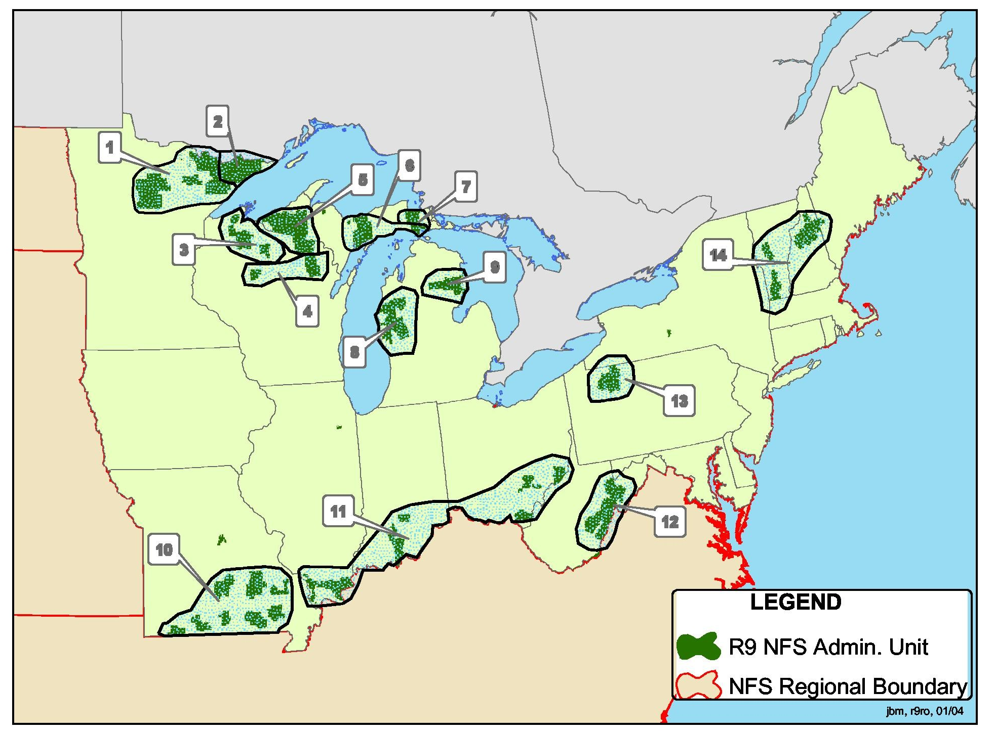
Figure 1 – The Region 9 Tree Seed Collection Zones devised in 1970.

New considerations in seed source selection

It is now recognized that locally collected seed is likely adapted, not to the climate at the site where it was collected, but to the climate that existed at the site early in the lives of the trees that produced the seed. Since trees are long lived, this suggests locally collected seed is adapted, not to the local climate, but to the climate that existed there 50 to 100 years ago. At least some of the seedlings being planted now should still be on the site where they were planted in another 100 years. Planting local sources of seed means that when the seedlings being planted reach maturity, they will be adapted to a climate that existed 150 to 200 years earlier. As was discussed earlier, climate is predicted to change enough during this length of time to affect the growth and survival of trees.
The natural processes of migration and evolution made it possible for the tree species in Region 9 and their constituent populations to survive the warming after the last ice age. These processes may not work fast enough to allow some tree species or their constituent populations to survive the changes in climate that are expected over the next 100 years. Models of migration of trees suggest that a number of tree species will not be able to migrate fast enough to keep up with the rate of climate change (Iverson et. al. 2004, Prasad et.al.2013). Not many people have tried to evaluate the probability that evolution will work fast enough to allow populations of trees to remain in place as climate changes. Rehfeldt and others (2001) did this for lodgepole pine and concluded that evolution was unlikely to be fast enough for populations in the United States.
If neither migration nor evolution are likely to be rapid enough to maintain healthy populations of native trees, there may be a role for humans to assist the movement of species and populations within species. This is commonly referred to as assisted migration or managed relocation. Past Region 9 Seed Use Guidelines have not allowed for this option. The most important difference between this document and the handbook supplement it replaces is to allow a conservative level of assisted migration in response to climate change.

New considerations in seed use

Work done in other parts of the country has shown that tree species differ in how far it is appropriate to move their seed. If specific guidance is available for a species to be planted, it should be followed. Unfortunately very little research of this sort has been done in the Northeastern and Midwestern United States. General guidelines have been developed that are meant to be applied to most species.
Region 9 now recommends a relatively conservative level of assisted migration. When selecting seed for operational reforestation on a particular site, seed should be chosen that comes from an area that has a climate now that is similar to what is expected at the planting site in 10 to 20 years. This agrees with recommendations made by a group of Forest Service geneticists (Erickson et. al. 2012). This may seem overly conservative, but it should be compared to Region 9’s previous guidelines that essentially required planting seed that was collected from sites that had a climate that is similar to what occurred on the planting site 50 to 100 years before. In very general terms, this means that in the future, appropriate seed sources are often going to be near the southern edge, or even south of the southern edge of forests. It is important to note that since the climate is expected to continue to warm over the next 100 years, the source of seed that is appropriate for a particular planting site will gradually move to warmer and warmer areas.
It may be difficult to obtain enough seed from many of the areas where it is needed to meet the needs of national forests. This is because the areas where seed is needed will often not be managed by the Forest Service and in some cases may be mostly non-forested. When difficulty in collecting seed is anticipated, it may make sense to collect a small amount of seed from each of a large number of trees in the seed collection area and use that seed to establish seed production areas for national forests. Since it can take 30 or more years for some tree species to start producing useful amounts of seed, these seed production areas should be established well before they are needed. The seed to establish seed production areas that will supply seed for the end of this century should be collected relatively soon.
Region 9 already owns large amounts of seed that were collected and labelled using the 1970 Tree Seed Collection zones. Although new seed should be collected using the guidelines described in this document, existing seed can be planted using the old guidelines. Forests may also use seed collected under the old guidelines for another forest when it meets the new guidelines. Forests planning to use seed collected for another forest should discuss this with the other forest and the manager of the Regional Seed Cache.
When Region 9 forests acquire seed from climates similar to what is predicted for the future, in many cases the seed will come from non-Forest Service lands and in some cases from lands outside of the region. The Region 9 Tree Seed Collection Zones must be updated to include all lands in Eastern United States. They should include areas between national forests and areas south of Region 9. An effort known as the Eastern Seed Zone Forum is developing a set of seed collection zones that meet these criteria. Once this effort is finished, Region 9 should use their terminology when requesting and storing seed. Alternative ways to describe seed origin would be by the county and state of origin or the latitude and longitude to the nearest tenth of a degree. In areas where differences in elevation exceed 1000 feet, the elevation should be specified as well. In some cases it may be important to recognize additional factors about a particular source of seed; for example, if the collection site was unusually wet or dry for that species or had an unusual soil chemistry.
In the past forests specified where seedlings were going to be planted and usually let the Manager of the J.W. Toumey Nursery select the seedlot to grow the seedlings. Because the new system will be more complex, forests will have to play a more active role in managing their seed. This will include deciding what sources of seed will be needed in the future, acquiring seed from those sources and working with the Nursery Manager to choose the seedlot to grow each seedling order.

Matching seed source to future climate

Figuring out what seed source to use for a particular planting site requires finding a source that has a climate now that is similar to the climate expected at the planting site at some point in the future. Climate analog tools are programs that match climates that exist at different locations or at different points of time. The Seedlot Selection Tool (SST) is a GIS-based climate analog tool that was designed specifically to match seed collection sites with planting sites. It was originally developed by Glenn Howe of Oregon State University and Brad St. Clair of the Pacific Northwest Station, and is hosted by the Conservation Biology Institute (a website tool that helps identify appropriate sources of seed).
The SST allows the user to choose from an array of climatic variables to describe the climate of interest. Populations of trees are primarily adapted to cold temperatures and water availability, so using a combination of temperature and moisture makes sense. A combination of extreme minimum temperature and growing season precipitation works well for many planting locations. The SST provides the value of the climatic variables that are selected at the location of a planting site that the user chooses. The user must then indicate how much deviation around each of these values is acceptable. In SST these deviations are referred to as transfer limits and SST provides a way to choose them. If the user selects the zone option and then selects one of the existing seed collection zones that includes the planting site, SST will provide the amount of variation in that zone for whatever climate variables have been chosen. The amount of variation in climatic variables that worked well for seed zones used in the past can help the SST user decide how much variation they are willing to accept in the future. Allowing extreme minimum temperature to vary by 5ºF (or the width of a USDA Plant Hardiness Zone) and growing season precipitation to vary by 20% seems to work well for at least some Region 9 forests. In any case, the objective of this part of the exercise should be to define a climate that delineates a geographic area from which it would have made sense to obtain seed in the past.
Once a geographic area has been defined where it would have been reasonable to obtain seed in the past, the next step is to find out how the climate within that area is predicted to change in the future and identify areas that have that climate now. These will be areas where seed can be collected that is adapted to future climates. This can be done with SST by changing the time frame for the climate of the planting site. When a time period in the future is chosen, the user can choose between a representative concentration pathway (RCP) of 4.5 (which assumes action to control concentrations of greenhouse gases is taken by the middle of this century) and 8.5 (which assumes greenhouse gas concentrations continue to increase).
This exercise has been done for all of the Region 9 national forests for most of the time frames offered by the Seedlot Selection Tool (1961 to 1990, 2011 to 2040, 2041 to 2070, and 2071 to 2100). A RCP of 4.5 was assumed which is somewhat optimistic and should be re-evaluated in the future. Maps that show locations of good climatic matches have been exported to Arc GIS and are available to all Forest Service users through Citrix (T:\FS\NFS\R09\Program\2400TimberMgmt\GIS\pberrang\Temp_and_Precip.mxd). This source should be consulted before planning seed collections because the user can access information like county lines, major roads and elevation. Seed source recommendations from these projections are summarized for each national forest in Region 9 at the end of this document.
When using the SST it is important to remember that this tool sometimes identifies areas that are good climate matches that may seem risky from other points of view. For example, there are some climatic similarities between parts of the Northern Great Lakes and parts of northern New England, but it seems prudent to only move seed within each area and to avoid moving it between such widely separated areas. Some discretion and judgement are required to determine which areas that are good climate matches are also the best places to collect seed.
It is also important to recognize that the species for which seed is desired may not occur at places that are good climate matches. When that happens the user will have to either collect seed from an area with a less than ideal climate match or choose another species.
In some cases, the most appropriate source for one part of a forest may be seed from another part of that forest. This might involve moving seed from the southern part to the northern part of a forest or from a low elevation area to a high elevation area of a forest.
Matching a seedlot to a planting site can be done more precisely when more is known about the origin of the seed. With this in mind, forests are encouraged to record more specific information about the origin of seed collected in the future than was common in the past.
Assisted migration may be difficult for forests that rely on natural regeneration and for species that are not planted. In these cases it may make sense to establish small, but genetically diverse plantings that are adapted to future climates. These can increase the potential for migration of seed or pollen. Brad St Clair and Glenn Howe (2009) refer to these as “genetic outposts.”

Seed Acquisition

This section provides more specific information on how to apply the general principles that have already been described.

Assessing Seed Needs

Most trees do not produce large amounts of seed every year. Instead, production of seed varies widely depending on weather, insect populations, and other factors. This means that enough seed must be collected and stored during good seed years to meet seed needs until the next good seed crop. Region 9 stores most of its tree seed in the Regional Seed Cache at the J.W. Toumey Nursery. In general, this means that there should be enough seed in the Seed Cache of the species desired for a particular area to last 5 to 10 years. This assumes the seed of the species desired can remain viable that long.
There are differences among species in how long seed can be stored. The seed of some species; for example, most pines, can be stored for long periods of time if it is collected when it is ripe, dried to 5 – 10% moisture and frozen. These are sometimes referred to as orthodox species. The seed of other species; for example, many oaks, can only be stored for a few months and are generally planted shortly after collection. These are sometimes referred to as recalcitrant species. With recalcitrant species, the time between good seed crops can sometimes be bridged by collecting and planting large amounts of seed during a good seed year and planting 1-0 stock the first year after collection, 2-0 stock the second year after collection, and 3-0 stock the third year after seed collection.
The length of time seed can be stored should be considered when determining how much seed is needed. Information on how long the seed of some tree species can be stored may be found in the Woody Plant Seed Manual, but finding out the seed requirements for other species may require a literature search.
When assessing seed needs, forests should consider the possibility that ideal sources of seed will shift over time. The area that is the best source of seed today may not be the best source of seed in 10 or 20 years.

10 Year Seed Plans

Each Forest should prepare an estimate of the seed it expects to use by species for the next 10 years. Some forests may need to prepare separate seed plans for different areas; for example, for different elevations within the forest or for lake-side areas and inland areas (Exhibit 1).
The 10-year Seed Needs should be updated every five years or more frequently if changes in seed needs are anticipated.
The 10-year Seed Plans will be used in conjunction with the seed inventory to determine if seed from a particular location or orchard block should be harvested. They will also be used to determine if requests for WCF funds to collect tree seed are justified. WCF funds will not be issued for seed collection unless there is a demonstrated need for the seed. These estimated seed needs should include both planned, as well as a reasonable level of unplanned, seed needs. Unplanned seed needs would include regeneration that could reasonably be needed as a result of fire, blow down, or insect outbreaks.
The number of seeds per pound can be obtained from the Woody Plant Seed Manual. Do not assume every seed will produce a plantable seedling. If there is good germination, one might expect the nursery will have to plant 2 or 3 seeds for each plantable seedling that is produced.
Seed needs also vary dramatically with the method of artificial regeneration. Direct seeding uses considerably more seed than planting seedlings. If seed is in short supply, seed can be conserved by planting seedlings instead of direct seeding.
The Region 9 seed inventory is summarized on the J.W. Toumey Nursery website.
Exhibit 1
Format for submitting 10-year seed needs.

POUNDS OF SEED NEEDED PER 10 YEAR PERIOD
 |  | TIME PERIOD |  |  | TO
FOREST | ZONE IN FOREST |  | SPECIES | SEED COLLECTION ZONE OR COUNTY, STATE |  | 10 YEAR NEED

Know the Origin of All Seed

Forest Service Manual stipulates that all seed or seedlings planted on National Forests be of known origin (FSM 2475.23).
Those responsible for the collection or purchase of cones or seeds should know the approximate location of the stand where the seed was collected. If seed is collected from a plantation, ideally they should know the origin of the seedlings used to establish the plantation. At a minimum they should verify that the trees in the plantation are healthy and well formed. If seed is collected from a seed orchard, they should know the origin of the seeds or clones used to establish the seed orchard. If seedlings are purchased from a nursery, the origin of the seed used by the nursery should be known.
Information on how to record the location of seed collections can be found in the section of this document entitled “Maintain the Identity of Seeds and Cones.”
The J.W. Toumey Nursery will maintain records of where seed was collected and the identity of the seedlot used to grow seedlings ordered by forests. When the nursery ships seedlings to forests, the identification of the seedlot used to grow the seedlings is shown on each package.
Problems associated with inappropriate seed sources may not become evident until decades after a stand is planted. Forests should maintain records of the identity of the seed source used to plant a stand throughout the life of the planted stand.
In the past, knowing the 1970 Tree Seed Collection where the seed was collected was considered adequate to meet the requirement to know the origin of the seed. Going forward, we will be able to do a better job of matching seedlot origin to the future climate of the planting site if the origin of seedlots is known more precisely.

Types of Collection Areas for Reforestation and Restoration

Seed for reforestation or restoration can be obtained from general collections, selected stands, seed production areas or seed orchards. These options will be evaluated by the criteria of local adaptation and genetic diversity. Seed from general collections, selected stands, seed production areas and seed orchards should be stored separately.

General Collections
General collections are collections of seed or cones that are known to be from a general area, but can not be attributed to a particular stand, tree or seed orchard. General collections are the least desirable source of seed because so little is known about them. Some general collections are from genetically diverse groups of trees, but this is not always true. Collections may come from open grown trees in landscape situations that may not be of local origin or may come from a limited number of trees. In spite of these concerns, general seed collections are common in Region 9.
In the past, general collections were typically acquired by placing a local advertisement and purchasing them from local casual collectors that brought them to a District Office. The need to collect seed from new areas means there will have to be some changes in this procedure going forward. One approach would be to continue to target casual collectors by advertising locally in the area from which seed is needed. One problem with this approach is that changes in government purchase regulations are making it more difficult to purchase seed from a casual collector. Another approach would be to purchase seed from another entity that also makes general collections, typically a state or county agency. A third approach would be purchase seed from reputable seed collectors in the area from which seed is needed. Forests are encouraged to keep a record of who sells seed to make it easier to find sources of seed in the future.
As more of forest’s seed is obtained from areas outside of national forests it is likely that use of general seed collections will increase.
When purchasing seed from general collections, the purchaser has a number of obligations. One is to verify that the seed is viable and of the correct species. A second is to determine that the seed is ripe or mature and not infested with insects. A third is to get as much information as possible on the source. Often, the collector is willing to provide only a general description of the locality of the collection; for example, the county of origin. It is not necessary to know the exact location where the seed was collected.

Selected Stands

Occasionally when seed for a forest was collected largely on that forest, particular stands on the forest were designated for collection. While this is not as likely to happen when seed is being collected from someplace other than a national forest, it is still important to keep in mind the guidelines when acquiring seed
- Try to avoid plantations, particularly if they are of unknown seed source. Many of our reproductively mature plantations were established during the Civilian Conservation Corps era when seed origin was not considered important. Under no circumstances should seed be collected from plantations of unknown origin if they have poor stocking or if the trees are unhealthy.
- Avoid genetic test plantations. The Regional Geneticist must be consulted before collecting seed from a genetic test plantation. Researchers and tree improvement workers sometimes establish test plantations with parents from a broad range of sources. It is generally unwise to collect seed from these plantations for operational reforestation. Sometimes a genetic test plantation may be thinned to convert it to a seed orchard. There is nothing wrong with collecting seed from properly converted test plantations.
- Avoid stands that have been subjected to repeated high grading. High grading tends to leave trees that are not well adapted to the local conditions.
- Try to avoid stands that were regenerated following a seed tree cut or other treatment that left only a few trees per acre. In these cases, many of the trees in the stand will be progeny of the same female parents and the seed collected from them may be the product of inbreeding. Seed produced by inbreeding tends to have poorer germination, express undesirable mutations when it does germinate, and grow slowly.
- When collecting seed from a designated stand, collect similar amounts of seed from at least 15 individuals. Ideally they should be scattered around the stand so they are separated by at least 100 feet. Consider storing the seed from each designated stand separately to maintain flexibility when the seed is deployed.
Seed Production Areas
Traditionally a seed production area was a natural stand that was managed for seed production. Management might include thinning, fertilization, improving access or protecting against seed predation. Old maps show that seed production areas were designated on some forests in Region 9 many years ago, but none appear to be in current use.

As climate changes, forests will need to collect seed from areas that are further and further from the forest. In some cases it may make sense to work with a forest from further south to establish a seed production area there. In other cases it may make sense to establish a seed production area on a forest with seed from further south. This may make sense when the recommended area for seed collection is in a place with very little public land and possibly very little forested land. This may make it difficult to collect large amounts of seed. When this is the case, forests could ensure future seed availability by establishing plantations designed specifically to produce seed for future use. These could be classified either as seed production areas or as untested seed orchards depending the level of management that is planned.
If plantations are established with the intention of using them for seed collection, take care to include adequate genetic diversity. The plantation should include offspring of at least 30 unrelated individuals and the parents should have been obtained from several different stands.
It may take 30 years, or even longer, for a seed production area to produce significant amounts of seed. This means these areas must be planted long before they are needed. It is not too early to start planting seed production areas that are designed to provide seed for the climates that are predicted for the end of this century.

Seed Orchards
Seed orchards are plantations that are established for the exclusive purpose of cone or seed production. Seed orchards are typically established for species for which large amounts of seed are needed, species for which special traits are needed (e.g. disease or insect-resistant material), or species that are difficult to collect seed from in the wild (e.g. hemlock or tamarack in some areas).
Establishing a seed orchard involves a sizeable investment. Because the seed from a seed orchard will be planted over a large area for a long period of time, it should include a larger number of unrelated parents; at least 30, but preferably more. Seed produced by each seed orchard should be stored separately.
The Oconto River Seed Orchard (ORSO) is located in northern Wisconsin and produces tree seed for national forests in the Northern Great Lakes States. It includes blocks of a number of different species from a number of different origins. The white pine, jack pine and black spruce seed from this orchard have been used regularly. Smaller amounts of other species are also produced. Blocks of oaks and scale resistant beech and are being established. ORSO is the only seed orchard in Region 9 with a dedicated staff, but it is not the only seed orchard for Region 9. The Mark Twain NF has a shortleaf pine seed orchard in Region 8 and uses seed from this orchard regularly. A number of other forests have seed orchards, but the seed is not collected or used very much.

Funding to Collect Seed for Reforestation and Restoration

A number of sources are available to pay for cone and seed collection. These include Working Capital Funds (WCF), appropriated funds (typically National Forest Vegetation and Watershed Management (NFVW), Knutson-Vandenberg Funds (KV), and Reforestation Trust Funds (RTRT). The rules for the collection and use of seeds varies depending on the source of these funds.
In the past the majority of the tree seed in Region 9 was collected for the Lake States Forests and for the Mark Twain National Forest. Appropriated funds and WCF were used to pay for collecting most of the seed for these Forests. In the future, other mechanisms such as Good Neighbor Authority or Stewardship may become important for acquiring seed.

Working Capital Funds (WCF)
WCF for tree seed is very similar to WCF for vehicles. WCF is generally only used for seed that will be stored for at least several years. Forests pay for their initial seed acquisition with appropriated funds and donate the seed to the WCF cache. Then the Forest pays a fee to withdraw the seed from this cache and WCF pays for the acquisition of new seed to replace what is withdrawn. The WCF program pays for the cost of cleaning and storing this seed. If Forests want to greatly increase the amount of their seed in the WCF cache, they must finance these increases with additional appropriated funds. The Forests that have traditionally used WCF to pay for seed acquisition can also choose to use appropriated funds.
Forests may be charged a fee for the cleaning of non-WCF seed or storing it in the Seed Cache at the J.W. Toumey Nursery. Forests should not have to pay a fee when they withdraw non-WCF seed from the Seed Cache.
Forests outside of the Northern Great Lakes States and the Mark Twain NF generally pay for acquisition of seed with appropriated funds. They can continue to do so or they can elect to participate in the WCF cache in the future. If this choice is made, their initial collections should be made with appropriated funds and donated to WCF.
WCF funds are not to be used for establishing and maintaining seed orchards or seed production areas. They can be used to pick seed or cones from a seed orchard or to extract or clean seed from a seed orchard.

Knutson-Vandenberg Funds (KV)
KV funds can also be used for some cone or seed acquisition. These funds are associated with particular projects. KV funds should be used only to collect or purchase seed for those projects and not to establish a seed cache for general reforestation. However, KV funds can be converted to K2 funds which may be available to support work outside the sale area.

Reforestation Trust Funds (RTRT)
In some cases RTRT funds can be used to pay for seed acquisition. The restrictions on the use of these funds is similar to those for appropriated funds. The Regional Silviculturist should be consulted before using RTRT funds to pay for seed collections.

National Forest Vegetation and Watershed Funds (NFVW)
Seed collected for the genetics program must be paid for out of appropriated dollars. The appropriate management code at this time is the National Forest Vegetation and Watershed Management (NFVW).

Good Neighbor Authority (GNA) and Stewardship Funds
Some state and some county agencies collect tree seed for their own use. They may already be collecting seed in areas that national forests are targeting for collections. It may be possible to acquire seed for reforestation on national forests through a GNA agreement. The Regional Authorities Coordinator should be consulted for more information on use of these funds.

Stewardship
Stewardship Contracting and Agreements can provide a source of local revenue from the selling of forest products to accomplish resource restoration. Tree seed can be included in an approved stewardship project as an appropriate item to be purchased by revenue generated in stewardship contracts or agreements.

Preparing for Cone and Seed Collection

As forests start to acquire more of their seed from areas outside national forest boundaries there will be less seed and cone collection on national forests. This may mean that in the future seed collection by Forest Service employees may be the work of special traveling crews. In addition more seed may be acquired by purchasing it.
- The first step of cone or seed collection is recognizing a need for seed, determining that the Seed Cache does not have enough appropriate seed to meet this need and deciding to obtain additional seed. Determine how much seed is needed and how much is available in the Seed Cache.
- If there is not enough seed available to meet the forest’s needs, it may be possible to buy genetically appropriate seed from a commercial source, although usually seed needs must be met by collecting seed or buying seed collected specifically for your needs.
- Determine how the cone or seed collection will be funded. This was discussed in more detail earlier in this document. If WCF will be used to pay for collection, apply to the J.W. Toumey Nursery Manager for authorization to spend WCF for seed collection. The application can be a simple electronic note, but it must include an estimate of the amount of seed to be collected and the estimate of the cost. Ideally these applications will be sent to the Nursery Manager at the start of the fiscal year (i.e. at the end of September). If cone or seed collection will be contracted, a contract must be developed well in advance.
- Well before cone collection starts you should learn some basic information on the biology of the species of interest for your Forest.
  - Identify potential parents. The ideal seed collection area will include a large number of individuals at a wide spacing that promotes flower and seed production.
  - Find out how to assess seed crops. The book entitled Seeds of Ontario Trees and Shrubs provides information on how to assess the potential for seed collection before the seed is ripe.
  - Learn the approximate date when the cones or seed are ripe and how to recognize ripe or nearly ripe cones or seeds.
  - Become familiar with the most common pests that attack the cones or seeds of the species in question.
- Figure out which of the various methods of collecting seed will work best for you. Identify the hazards associated with the methods you propose to use and prepare a job hazard analysis. Determine who will collect the seed. If a contractor will be used, prepare a contract well in advance.
- Find out what needs to be done with the cones or seeds after they are collected. Where will the cones or seeds be stored until they are shipped? How long can they be stored without loss of seed quality of viability? Do they have to be protected from rodents or insects? Do they have to be cleaned, or otherwise processed? Who has done this work in the past? Will they be available this year?
- Cone or seed collections should occur only during good seed years unless seed is urgently needed. Collecting during good seed years decreases the cost per pound of seed and increases the genetic diversity of the seed.
- Monitor the development of the seed crop on potential parents. In most cases, monitoring of the cone or seed crop starts the spring before collections are planned. With pines, cones can generally be counted starting in June. Tables in the Woody Plant Seed Manual (USDA FS 2008) can be used to estimate how many cones should be picked to meet your seed needs.
- For many species it is wise to determine if the cone or seed crop is being attacked by insects. This can often be combined with monitoring the development of the cone or seed crop. Some insect problems can be recognized because the cones or seeds develop abnormally. Don’t pick cones or fruits that are not properly formed. Some insect damage is not visible, particularly when it is confined to seeds inside the cones or other fruiting structures. Entomologists with the State and Private Forestry portion of the Forest Service can help diagnose potential seed and cone insect problems.
- Seed stores and germinates best when it is collected when it is ripe or nearly ripe. Cones or seeds should be picked when they are as ripe as possible, but before they are lost to seed fall or rodents or birds. The seed of some species continues to ripen after it is collected. If that is the case, additional time must be allowed. Information on after ripening can be found in the Woody Plant Seed Manual. Two useful references for figuring out when to collect tree seed are Seeds of Ontario Trees and Shrubs” (Ontario Seed Plant 2014) and “Seeds of Woody Plants in the US” (USDA FS 2008) (online version of book available at website of the National Seed Lab of USDA Forest Service).

Methods of Cone and Seed Collection

Collecting cones or seeds from large trees can be a difficult and dangerous job. A wide variety of techniques are available. Some techniques require special training, authorization or equipment. Job Hazard Analyses should be consulted or prepared before work begins.

From the Ground
For some large seeded trees such as oaks, walnuts or hickories it may be most expedient to collect seed from the ground. Small amounts of these large seeds can be collected by hand. If a large amount of seed is needed, a number of manufacturers make machines that will pick up these large nuts. In some cases, the first seeds that fall are of poor quality. It may be most efficient to wait until after seed fall has started to make collections. Cones or seeds that are left on the ground for extended periods may be collected by animals or contaminated by disease. You may want to collect seeds from an area several times during the time when seeds are dropping.

Using a Pole Pruner
Seed or cones can be collected from smaller trees using a pole pruner. Generally, these are really only suitable for collections of relatively small amounts of seed or checking to see if seeds are ripe. Do not use a pole pruner that has a metal handle and do not use pole pruners where accidental contact with an electrical line is possible. Personal protection while using a pole pruner should include eye protection.
For some species such as ashes, maples or cherries you can spread tarps under the trees and collect the seed when it ripens and falls naturally. It may be possible to speed up the seed drop once the fruit is ripe. In smaller trees this can sometimes be done by beating the seed-bearing branches with long flexible poles. In larger trees it may be possible to shake the crowns with ropes that have been placed in the crowns with a large sling shot.

After Felling
For some species the easiest way to obtain seed or cones from tall trees is to pick it after the trees have been felled. This can allow large amounts of seed to be collected rapidly with relatively unskilled labor. Obviously, the drawback of this approach is that the parents that are chosen for collection will not be available in the future.
Sometimes cone or seed collections can be coordinated with a timber sale. This will require previous coordination with the Timber Contracting Officer and the timber purchaser. There are a number of difficulties with this approach. One is that, for most species, the trees need to be felled when the cones or seed are ripe or nearly ripe. It may be difficult to convince loggers to fell trees at the optimum time. Another problem is that seed and cone collectors need to enter the site after felling. Collecting seed on an active timber sale is dangerous and it may be difficult to convince a logging contractor to stop operations in an area after the felling. This approach will be most practical for species where the timing of the collection is not critical; for example, with serotinous jack pine or pitch pine.
Another way to collect cones or seed from felled trees is to fell trees specifically for cone or seed collection. There are a number of difficulties with this approach as well. You must obtain written approval from the appropriate line officer to fell trees. The faller must have the appropriate chainsaw certification. When trees are being felled specifically for seed collection, some people are inclined to fell as few trees as possible. This will greatly limit the genetic diversity of the collection. It is better to fell 15 or so trees and use the seed for a longer period of time.

Firearms
In many cases, the only alternative is to collect seed from standing trees. Very small amounts of cones can be collected from standing trees by shooting branches out of them. The most frequent application for using firearms in seed collection is when evaluating seed crops for ripeness or insect damage prior to collection.
Obviously, there is some risk to people in the surrounding area when using firearms. This technique is not appropriate for populated areas. All shooters must be authorized by the Forest Supervisor. All shooters must have special training and participate in a random drug screening program.

Climbing
Larger amounts of cones or seed can be collected from standing trees by climbing them. Climbing can be dangerous and physically challenging. All climbers must have special training and certification which must be renewed every 3 years. Climbers must be accompanied by another certified climber and both require a sizeable amount of equipment.
It may be possible to contract for climbing services or obtain certified climbers from fire crews or other national forests. Unfortunately fire crews are often busy with fires at the time seed or cones must be collected. More information can be obtained from the Regional Silviculturist or from the Dorena Genetic Resource Center in Region 6.

Mechanical Lift
The fastest way to collect large amounts of seed from large standing trees may be with a mechanical lift. This approach has drawbacks as well. The equipment is expensive to buy or rent. Although some special training is required to operate the equipment, these skills can be acquired more quickly than learning to climb. Some equipment is mounted on large trucks and a Commercial Driver’s License may be required to operate these trucks on public roads . The equipment that is not mounted on trucks does not travel fast enough to move it long distances. Some lifts can only operate on a limited range of slopes and can not drive over logs and rocks.
In most cases, mechanical lifts will only be practical in a seed orchard, a developed seed production area, or along a road.

Maintain the Identity of Cones and Seed

It is very important to maintain the identity of the seed source. When the cones or seeds are collected they should be put in a container and labeled. In most cases, freshly collected cones or seed should be stored in a cloth or mesh bag that will allow moisture to escape. A label should be placed inside and outside each bag or other container as soon as the seed is collected.
Cone Identification Tags should be used for this purpose regardless of whether the collection consists of seed or cones. These tags are available from J.W. Toumey Nursery. If Cone Identification Tags are not available, the bags should be tagged with the equivalent information. The tags should be filled out with indelible ink. Tags should be placed inside and outside the bag.
The tag should identify the:
1. Species
2. Name of the person making the collection or buying the seed.
3. Date of the collection
4. Forest the seed is being collected for.
5. Location where seed was collected. Minimal location information shall include:
a. Seed Origin Zone
b. State and County
6. Additional location information could include one of the following:
- Latitude and longitude of the collection area the nearest tenth of a degree.
- Range and township of the collection area.
- Forest, stand and compartment of the collection area.

The tag also should describe the:
1. Type of collection (general, select stand, seed production area or seed orchard).
2. Number of trees from which the seed was collected.

This information and additional details should be maintained at the District as well being sent to the nursery. When the seed arrives at the nursery it will be assigned a seed lot number and any location information provided will be recorded. Ideally the seedlot number would also be recorded at the District along with the information about the seed or cone collection. This will make it easier for a district or forest employee to determine which seedlots in the Seed Cache are most appropriate for their future planting needs.

Care of Cones and Seed After Collection

All cones or seeds should be placed in a container at the point where it is collected. The type of container that should be used will vary depending on the species. The seed of some species should be dried after collection while the seed of other species should be kept moist. Consult a reference beforehand and have the appropriate containers on hand before collection.
Cones should usually be placed in a burlap bag or some other container that allows air to circulate through the cones or seeds. Air circulation allows moisture to escape. Some cones and seeds are still physiologically active at collection and generate heat. Air circulation can also help dissipate some of this heat.
Twigs and other large trash should be removed from the seed before it is bagged.
Try to keep needles out of the bags of cones because they can also lead to high temperatures.
Most bags of cones should only be filled halfway to allow room for the cones to open. However, burlap bags of jack pine which are serotinous can be filled.
Do not use bags with a mesh that is large enough for the seeds to fall out if the cones will open.
Cones should be collected when they are dry. If this is not possible, as soon as they arrive at a temporary storage area they should be removed from the containers, allowed to dry out, and returned to the containers.
Cones can be stored locally for a short while after collection. However, they must be stored in a cool, shaded area and placed on racks that allow good air circulation through and between the bags. Ensure the cones will not be eaten by rodents or other animals while they are being stored. Maintenance of seedlot labels during this process is essential.
Cones will have to be shipped to a place where the seed can be extracted. At this time, seed from cones for the Lake States National Forests is extracted either at ORSO or by state natural resource agencies. ORSO should be contacted prior to shipping, as they have a limited capacity to do this type of work.
Forests outside the Lake States should look for an extractory that is closer than ORSO. Ensure the extractory has experience with your species, cleans previous seedlots from their equipment before processing your cones, and keeps your seedlots separate from each other. State nurseries often have equipment for extracting seed from cones.
Procedures for handling non-conifers after collection vary greatly. The procedures for collecting, storing and shipping them should be determined ahead of time. For example, ash seed should be collected after it has dried and allowed to continue to dry while acorns should be only be surface dried and stored under conditions that maintain a high moisture content. Seeds of fleshy-fruited species (e.g. black cherry or mountain-ash) will start to decompose soon after they are picked. They should not be allowed to heat up, decompose or dry out. It is best to ship them to the J.W. Toumey Nursery or the place where the seed will be cleaned immediately after collection. If this is not possible, store the seed in plastic bags in a refrigerator until they can be shipped.
Large nuts (e.g. oaks, walnut or butternut) should be shipped to the J.W. Toumey Nursery or the place where the seed will be cleaned shortly after it is collected. If this is not possible, they should be kept in a cool shady area. These large nuts should be spread out in layers that are no more than several nuts deep.
Seeds with samaras (e.g. maples, ash or elms) should be shipped to J.W. Toumey Nursery or the place where the seed will be cleaned shortly after they are collected. If this is not possible, they should be stored in a cool shady area. Spread them out in shallow trays so the air can move through them. Be sure the wind does not blow them away or mix seedlots. If in doubt call the J.W. Toumey Nursery or the place where the seed will be cleaned for instructions.
Additional sources of information on this topic include The Woody Plant Seed Manual and the staff of the J.W. Toumey Nursery.
The J.W. Toumey Nursery or the place where the seed will be cleaned should be contacted prior to shipment. Ensure that shipments do not arrive on a weekend, on Friday or the day before a holiday.

Seed Collections for Species Conservation

The genetic diversity or even the survival of rare species or small populations within rare species can be threatened by the loss of individuals or populations. In these cases it is not unusual to preserve a representative sample of the species or population by collecting and preserving seed. Fortunately most tree species consist of many populations that include large numbers of healthy individuals and it is safe to assume that the genetic diversity of the species is being preserved in these natural populations. However, there are occasional exceptions to this general rule. One is when an exotic or emerging insects or diseases kills the vast majority of individuals of a species. Region 9 has more damaging, invasive forest pests than any other part of the country and more continue to arrive every year (Liebhold et.al. 2013). In many cases native tree species have no resistance to these pests and in some cases they are expected to kill more than 90% of the individuals of important tree species. When this happens the genetic diversity of a once common species may be threatened. Pests of current concern include hemlock wooly adelgid, emerald ash borer and butternut canker.
In these cases it may make sense to preserve representative samples of some populations before they are lost. If the seed stores well, that is usually the most economical way to preserve them. Small samples of seed can be stored under ideal conditions at the National Center for Genetic Resources Preservation (NCGRP), a USDA Agriculture Research Service (ARS) facility in Fort Collins, CO. It is often best to work through the National Seed Laboratory, a Forest Service facility in Dry Branch, GA rather than directly with NCGRP. NCGRP makes small samples of seed available for limited types of projects. If larger amount of seed will be needed for restoration or plant breeding purposes, it may make sense to also preserve a working collection of seed at a Forest Service facility.
Designing seed collections for gene conservation or species conservation purposes takes special expertise. Forests should consult with a geneticist or species conservation specialist before making these collections. Samples should capture a representative sample of the genetic diversity of the population or species. Take care not to collect so much seed of rare species that natural reproduction is threatened.

Recommendations for Region 9 Forests

The Seedlot Selection Tool has been used to develop recommendations for all of the Region 9 forests. The actual output of numerous SST runs can be viewed through Citrix at the following location: (T:\FS\NFS\R09\Program\2400TimberMgmt\GIS\pberrang\Temp_and_Precip.mxd). This source should be consulted before planning seed collections because the user can access information like county lines, major roads and elevation. This document will describe recommendations for the next 20 years.
To facilitate the discussion in this document, the areas with good climatic matches that are recommended for seed collection are shown for each administrative unit in Region 9 (Figures 2 – 25). The areas outlined in red are recommended for collecting seed now and the areas outlined in black are recommended for collecting seed starting around 2030. These areas represent climatic matches and it is entirely possible that the species a forest needs seed for may not occur in these areas. Additional options for these time frames can be found by accessing the maps available through Citrix that were mentioned earlier. The same set of maps also has maps for other time frames, including one that would be used if one believed there had not been any climate change (1961-1990) and one that would be used if you wanted to establish a seed production area to provide seed for late in this century (2071-2100).
These guidelines should be considered as recommendations. Each forest will have to identify their species and seed sources based on these recommendations, their Land Management Plan and knowledge of conditions at the planting site. The Regional Geneticist should be consulted to help resolve ambiguous choices.
These recommendations should be re-evaluated at least every 10 years to determine if they need to be revised.

Allegheny National Forest

The Allegheny NF is located on the Allegheny Plateau in northwestern Pennsylvania. It does not have large elevational gradients and it has not been necessary to divide the Forest up into separate seed collection zones in the past.
At this time, the vast majority of regeneration on the Forest is established naturally. In the future the Forest may elect to plant trees on some sites to introduce populations that are adapted to future climates or to increase species diversity.
The climatically appropriate place to obtain seed now for operational reforestation on the Allegheny NF would be on the Allegheny Plateau in southern Pennsylvania. Starting around 2030, seed collections should shift further south to northwestern West Virginia (Figure 2).

Chequamegon National Forest

The Chequamegon NF is located in northwestern Wisconsin and is the western part of the combined Chequamegon-Nicolet NF. It does not have significant elevational gradients. In the past this unit was divided into northern and southern tree seed collection zones. While there are north to south differences in climate within this area, they are not large and in the interest of simplifying this discussion, they will be ignored.
The Forest has an active forest management program which includes a fair amount of artificial regeneration.
The most climatically appropriate place to obtain seed now for operational reforestation on the Chequamegon NF would be from central Wisconsin. A close approximation might involve moving seed collected from the Medford District to northern parts of the unit. Starting around 2030, seed collections should shift further south and west to northeastern Iowa and nearby parts of southwestern Wisconsin (Figure 3).

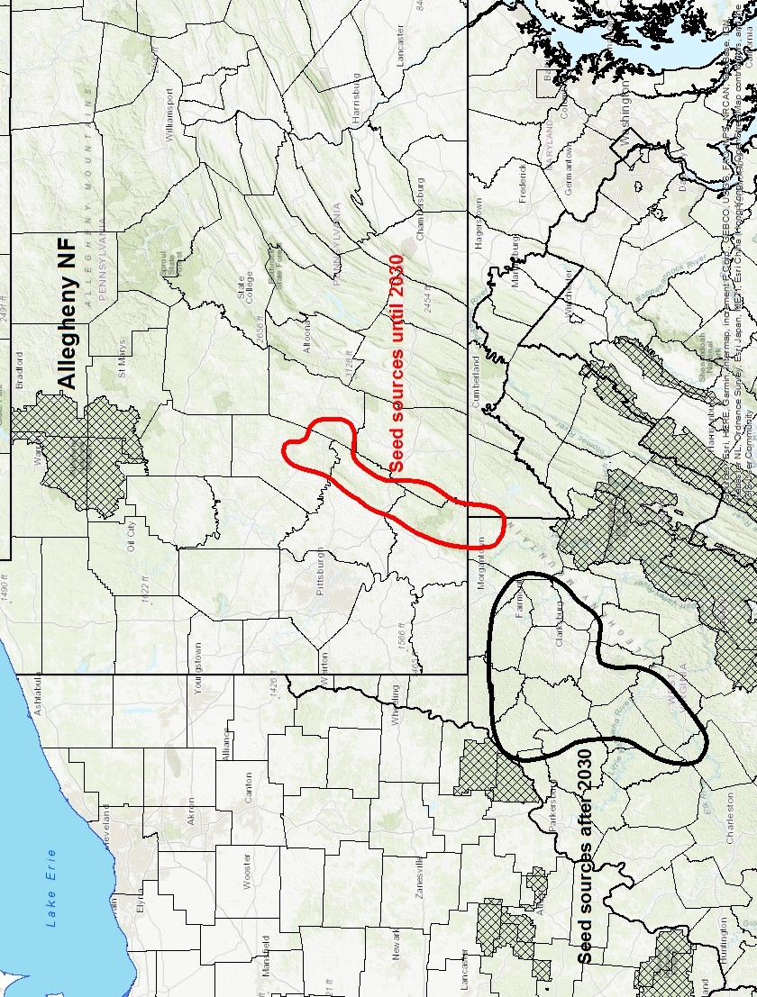
Figure 2 – Seed sources for the Allegheny NF, now and after 2030.
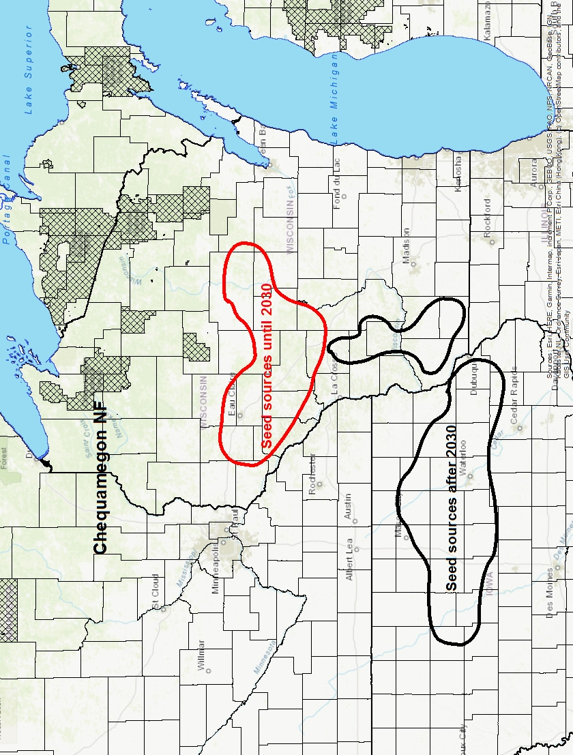
Figure 3 - Seed sources for the Chequamegon NF, now and after 2030.

Chippewa National Forest

The Chippewa NF is located on the edge of the prairie in northern Minnesota. It does not have significant elevational gradients and it has not been necessary to divide the forest up into separate seed collection zones in the past.
The Forest has an active forest management program which includes a significant amount of artificial regeneration.
The most appropriate place to obtain seed now for operational reforestation on the Chippewa NF is central Minnesota to the northwest of Minneapolis. Starting around 2030, seed collections should shift further south to southwestern Minnesota (Figure 4).

Finger Lakes National Forest

The Finger Lakes NF is located in a climatically complex area in central New York. The low point of the Forest along Seneca Lake is 1400 feet lower than the high point, but because the Forest is tiny it will be considered as one tree seed collection zone.
A lot of the Forest is pasture rather than forest. There has been very little forest management or artificial regeneration in the past. The Forest may choose to plant some trees in the future to introduce trees that are adapted to future climates or to replace invasive species.
Use of the Seedlot Selection Tool indicates there are many widely scattered areas that are climatically similar to the Forest. Some of these areas are a long way from the Forest and probably not good choices for areas to collect seed. Two possible tree seed collection areas were selected, one in the Ridge and Valley Province of central Pennsylvania and the other on Allegheny Plateau west of Pittsburgh, PA. After 2030, seed collection in both areas should shift to the south; either in southeastern Pennsylvania or in northwestern West Virginia (Figure 5).

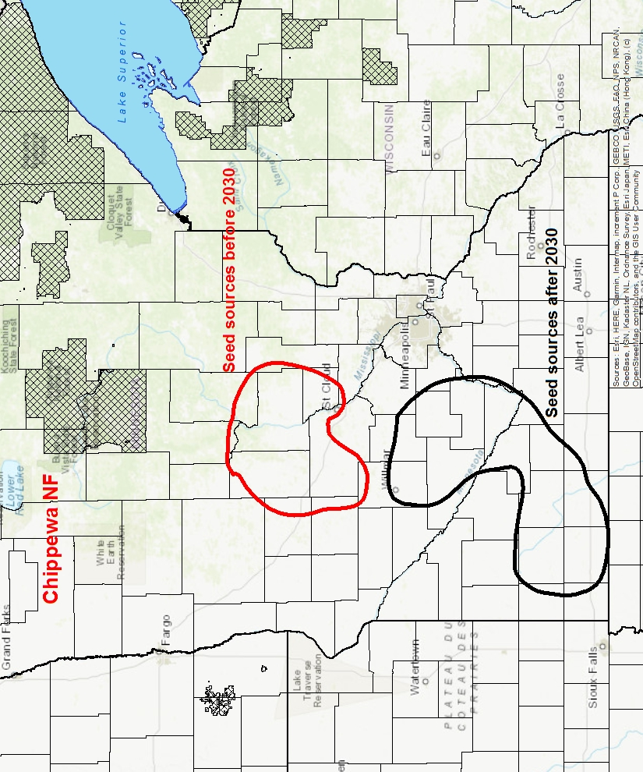
Figure 4 - Seed sources for the Chippewa NF, now and after 2030.
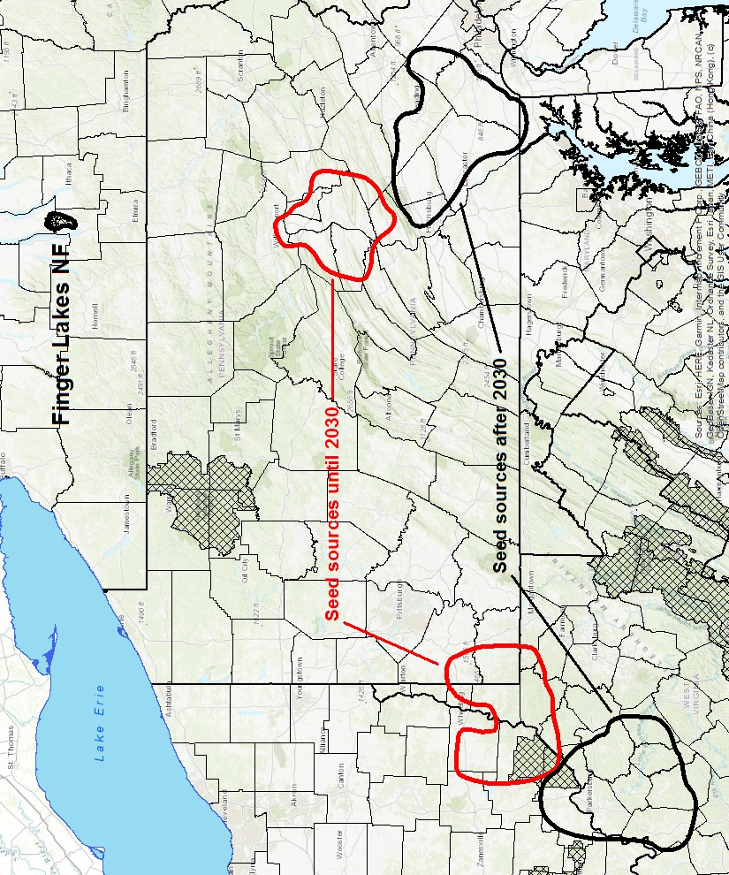
Figure 5 - Seed sources for the Finger Lakes NF, now and after 2030.

Green Mountain National Forest

The Green Mountain NF is in southern Vermont near the northern end of the Appalachian Mountains. Elevations on the Forest extend from less than 1,000 feet to more than 4,000 feet although most forest management occurs on the lower end of this range. The 1970 Tree Seed Collection Zones included all of the Green Mountain and White Mountain NFs in one zone and did not address these differences in elevation. This range of elevation is large enough to assume that population differences have developed for some species and that the forest should be subdivided on the basis of elevation.
Almost all regeneration on the Green Mountain is natural. In the future the Forest may elect to plant some sites to introduce trees that are adapted to future climates. There will be separate discussions on where to get seed for high elevations (above 2000 feet) and low elevations (below 2000 feet).
There are very few climatically appropriate places to obtain seed for operational reforestation now at high elevation on the Green Mountain NF. One logical area is from lower elevations on the same Forest. Areas with similar climate can also be found in a small part of the southern Adirondacks and the Catskills. After 2030 the best place for collecting seed for operational reforestation is predicted to be a small area at high elevation on the Monongahela NF. This big shift from collecting seed in the Northeast to collecting seed in the southern Appalachians is somewhat unexpected and should be approached cautiously. It should be re-evaluated closer to 2030. It would be wise to try moving seed such a long ways on a limited basis before doing it at a large scale (Figure 6).
There are several climatically appropriate areas in Pennsylvania to obtain seed now for operational reforestation at low elevations on the Green Mountain. One relatively large area surrounds the Allegheny NF and the other is in the northern part of the Ridge and Valley Province. After 2030 these areas are expected to shift further south on the Allegheny Plateau and the Ridge and Valley Province (Figure 7).

Hiawatha National Forest

The Hiawatha NF is located in the eastern end of the Upper Peninsula of Michigan. The 1970 Tree Seed Collection Zones divided the Forest into two zones, but use of the Seedlot Selection Tool suggests that differences between the two former zones are small. The Forest has an active forest management program that includes a good bit of artificial regeneration.
Most of the climatically appropriate areas to collect seed for operational reforestation on the Hiawatha now are in the Lower Peninsula of Michigan. At this time seed should be obtained from a doughnut-shaped area that encircles the upper half of the Lower Peninsula. After 2030 seed should be obtained from an area in the lower half of the Lower Peninsula (Figure 8).

Hoosier National Forest

The Hoosier NF is in southern Indiana. Most regeneration on this forest is natural. Climatic variation within the Forest is limited and the 1970 Tree Seed Collection Zones placed the Hoosier in a single zone along with the Wayne and Shawnee NFs.
Before 2030, most of the climatically appropriate areas to collect seed for the Hoosier are in western Kentucky. After 2030, seed collection should shift somewhat south to include far western Kentucky and western Tennessee, the Bootheel of Missouri, and northeastern Arkansas (Figure 9).
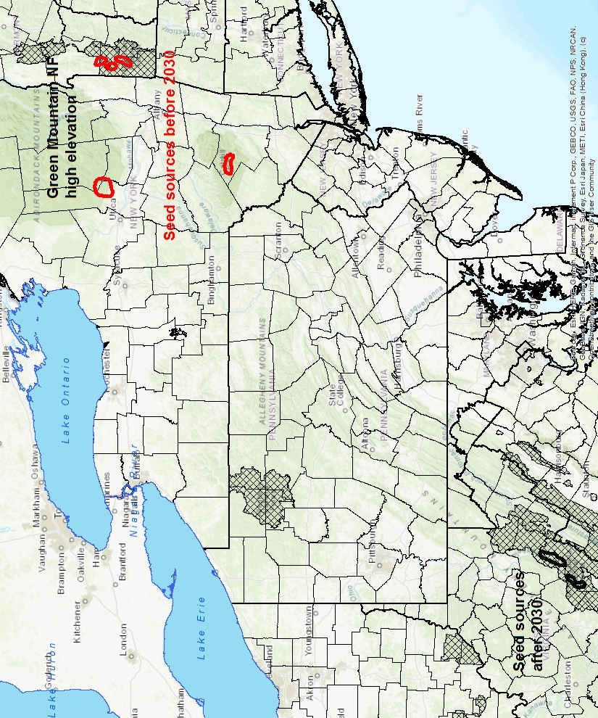
Figure 6 - Seed sources for high elevation on the Green Mountain NF, now and after 2030.
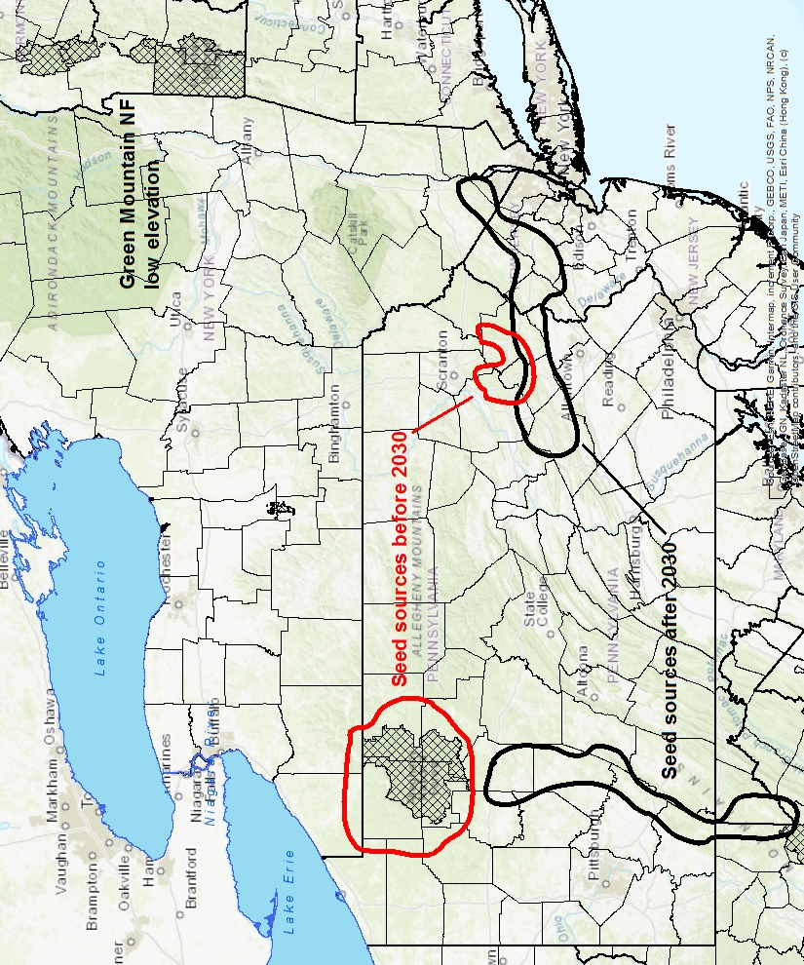
Figure 7 - Seed sources for low elevation on the Green Mountain NF, now and after 2030.
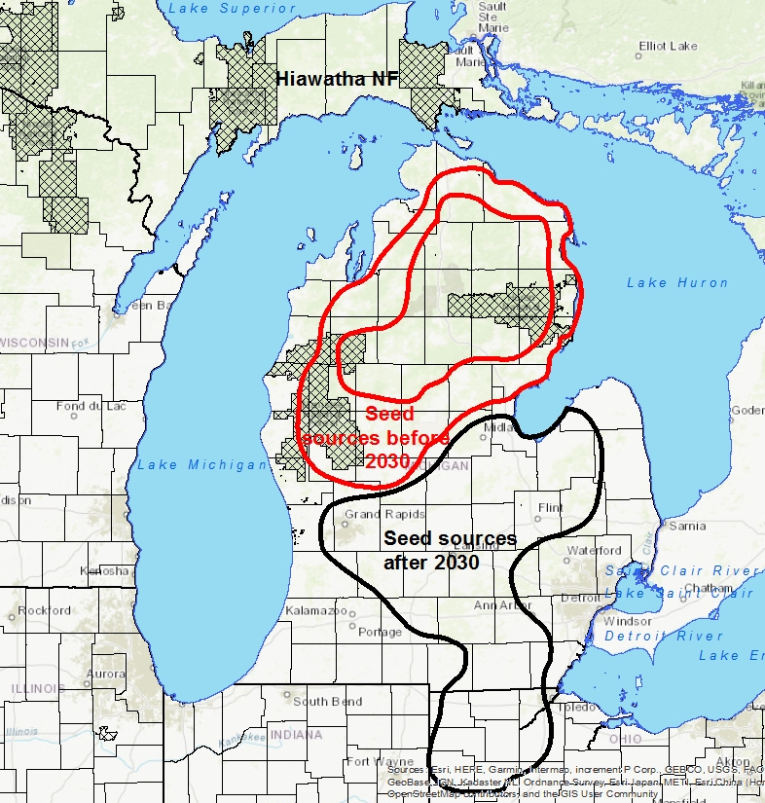
Figure 8 - Seed sources for the Hiawatha NF, now and after 2030.
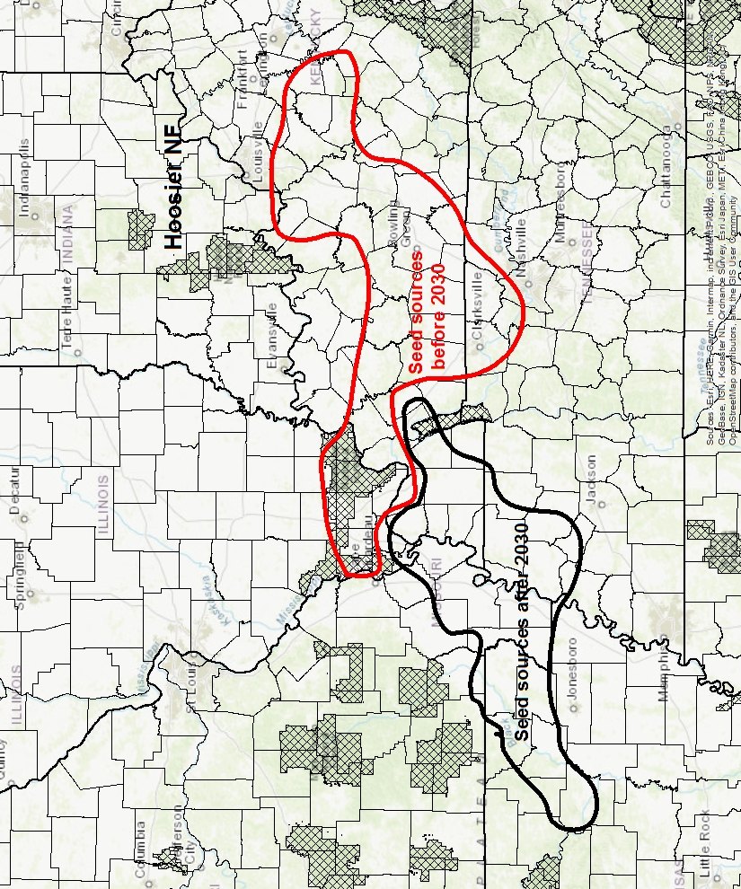
Figure 9 - Seed sources for the Hoosier NF, now and after 2030.

Huron National Forest

The Huron NF is located on the eastern side of Michigan’s northern Lower Peninsula. Climate on this forest is not affected by elevation, but does vary with proximity Lake Huron. The center of the peninsula has lower mid-winter temperatures than the areas along the lake. The Forest has an active forest management program. It includes a large amount of artificial regeneration, much of which is meant to produce habitat for Kirtland’s warbler.
Up until 2030, the most appropriate place to collect seed is south of the Forest on the east side of the Lower Peninsula. After 2030, the most appropriate place to collect seed will shift to the southeastern corner of the Lower Peninsula (Figure 10). Little or no jack pine to be found in the areas outlined on this figure. Although these are the largest areas with a good climatic matches, consulting the more detailed maps available through Citrix will show alternative collection areas where some jack pine is present.

Manistee National Forest

The Manistee NF is managed from the same supervisor’s office as the Huron NF. The Manistee NF is on the western side of the northern Lower Peninsula. It is similar to the Huron NF in that elevation is unimportant, but climate varies with proximity to Lake Michigan.
Before 2030, seed for operational reforestation on the Manistee NF should come from certain parts of northern Ohio and Indiana. After 2030 the best place for collecting seed for operational reforestation is predicted to be at low elevations along the flanks of the southern Appalachians. This big shift from collecting seed in the Upper Midwest to collecting seed in the southern Appalachians is somewhat unexpected one and should be approached cautiously. It should be re-evaluated closer to 2030. It would be wise to try it on a limited basis before implementing it on a large scale (Figure 11).

Mark Twain National Forest

The Mark Twain is located on the Ozark Plateau in southern Missouri. It is a large forest and is composed of 9 sections that are spread most of the way across the state. This is a long way to move seed, but the variation in climate across the forest is minimal except for the Cedar Creek Unit which is further north than the rest of the forest.
The Forest has an active forest management program which includes planting a fair amount of shortleaf pine. Currently seed for planting comes from a block of shortleaf pine from the Mark Twain that is located at a Region 8 shortleaf pine orchard on the Ouachita NF.
Before 2030, the best climatic match for the Mark Twain NF is a strip that runs along the boundary between Missouri and Arkansas and extends into western Kentucky. Significant amounts of shortleaf pine are only found in the western part of this strip. After 2030, the best climatic match for the Mark Twain NF shifts slightly south to include a strip that runs across northern Arkansas and extends into western Tennessee (Figure 12).
A close approximation of this might be to use shortleaf pine seed from the Mark Twain orchard block on the Ouachita NF for planting on the northern parts of the Forest and seed from one of the R8 orchard blocks on the Ouachita NF for the southern parts of the Forest.
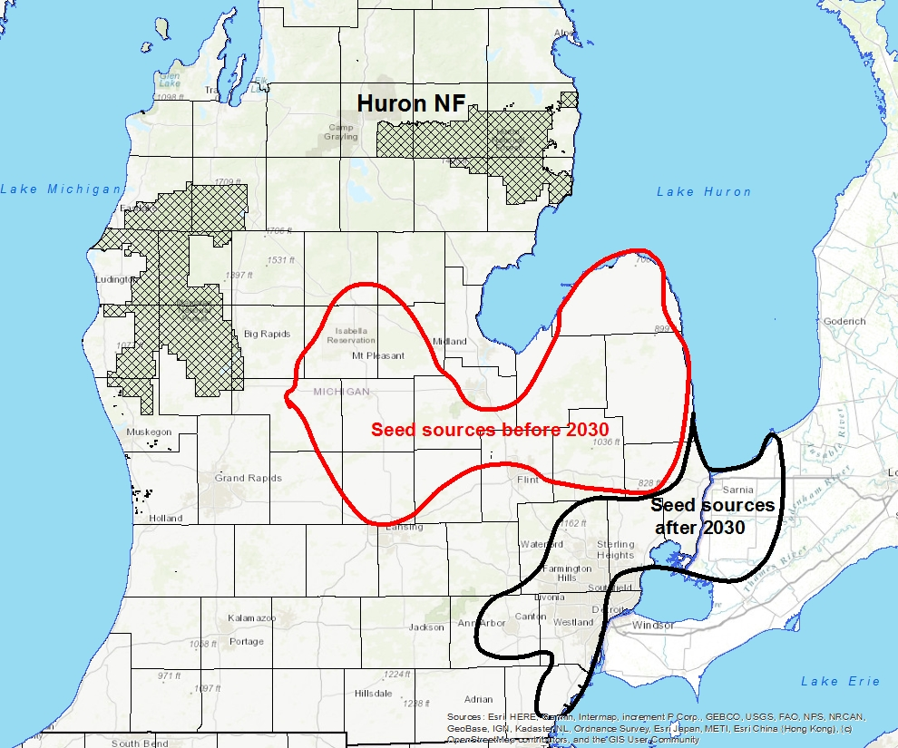
Figure 10 - Seed sources for the Huron NF, now and after 2030.
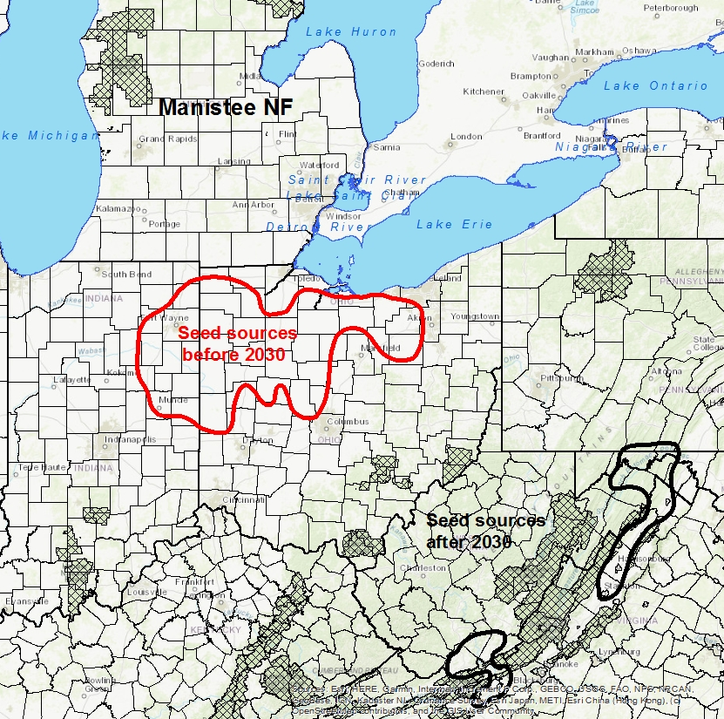
Figure 11 - Seed sources for the Manistee NF, now and after 2030.
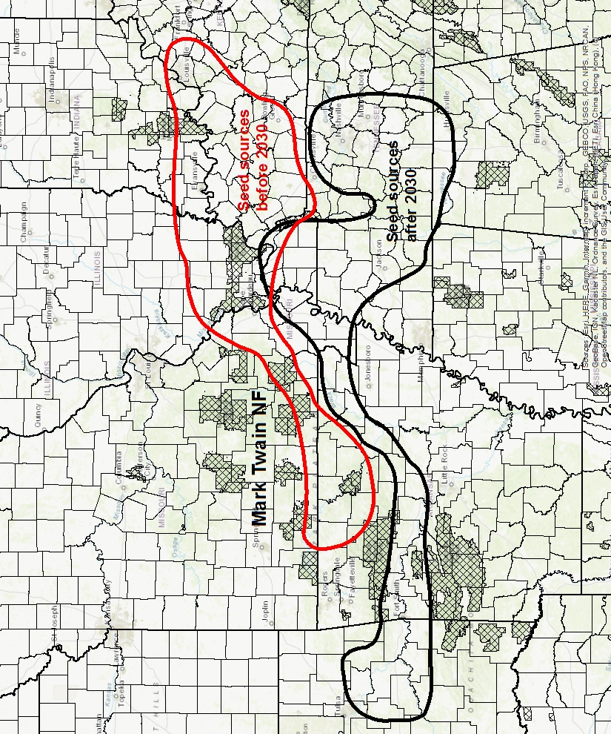
Figure 12 – Seed sources for the Mark Twain NF, now and after 2030.

Midewin National Tallgrass Prairie

Midewin NTP is located in northern Illinois. The focus of the Prairie is to restore herbaceous communities and little or no tree planting has been done or is planned. It is included in this discussion for the sake of completeness, not to suggest that trees should be planted on the Prairie.
The Seedlot Selection Tool suggests that before 2030, an appropriate source of seed for the Midewin TGP would be a strip across central Illinois and nearby parts of Missouri. After 2020, appropriate sources of seed would shift south to southwestern Illinois and nearby parts of Missouri (Figure 13).
The recommendations in this guide are based on predictions for extreme minimum temperature and summer precipitation. Different climate parameters might be more important for herbaceous plants.

Monongahela National Forest

The Monongahela NF is located in the southern Appalachians and extends into the Ridge and Valley Province on the east and the Allegheny Plateau on the west. Elevations range from less than 2500 feet to more than 4500 feet although most forest management occurs on the lower end of this range. Almost all regeneration on the Monongahela is natural. In the future the Forest may elect to plant some sites to introduce trees that are adapted to future climates.
The 1970 Tree Seed Collection Zones put all of the Forest in one zone and did not address these differences in elevation. This range is large enough to assume that population differences have developed for some species and that the forest should be subdivided on the basis of elevation. There will be separate discussions on where to get seed for high elevations (above 3,000 feet) and low elevations (below 3,000 feet
Before 2030 the most appropriate places to collect seed for high elevation sites on the Forest will be low elevation areas on the Forest. Because of the steep terrain on this Forest, it will be more important to focus on the elevation of the seed collection than its location. Before 2030, seed for high elevation areas on the Forest should be collected from areas that are 500 to 1000 feet lower than the planting sites. After 2030, seed for high elevation areas should be collected from areas that are just to the west of the Monongahela NF (Figure 14).
It appears that future seed sources for low elevation areas on the east and west sides of the forest are different. For this reason, they will be discussed separately.
Before 2030, the most appropriate places to collect seed for low elevation sites on the west side of the Monongahela NF will be areas that are just to the west of the Forest. These seed collection areas should be about 500 feet lower than the planting site. After 2030, the most appropriate areas to collect seed for these sites will shift south; to just south of the Daniel Boone NF in Tennessee and the foothills of the southern Appalachians in northern North Carolina (Figure 15).
Before 2030 the most appropriate places to collect seed for low elevation areas on the east side of the Monongahela NF will be low elevation areas just south of the Forest in West Virginia and Virginia. After 2030, the most appropriate areas to collect seed for these sites will shift south to the southern Appalachians in Virginia. There are also some areas that are climatically appropriate at lower elevations in the Ridge and Valley Province of Pennsylvania as well (Figure 16).
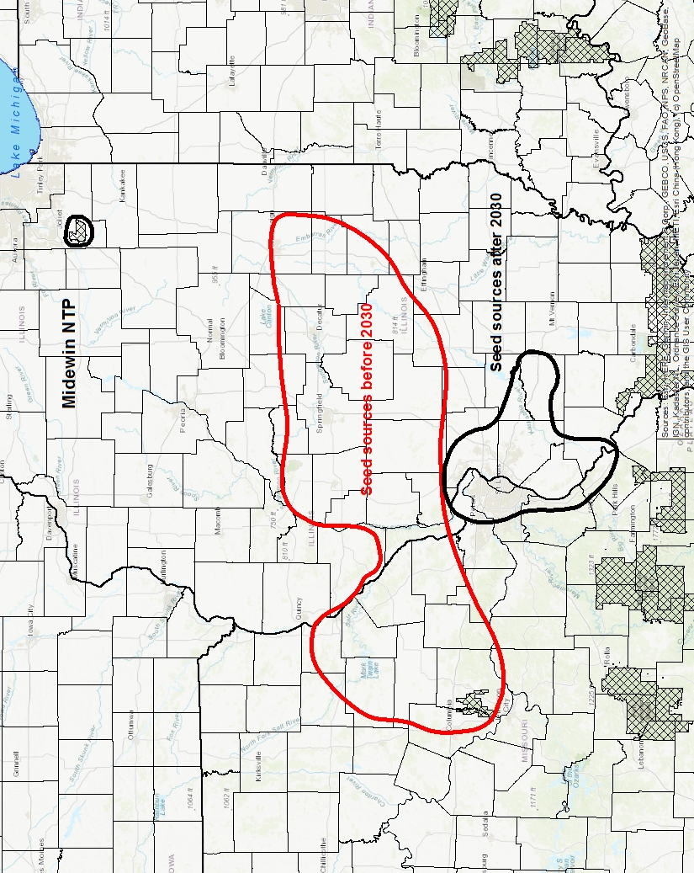
Figure 13 - Seed sources for the Midewin NTP, now and after 2030.

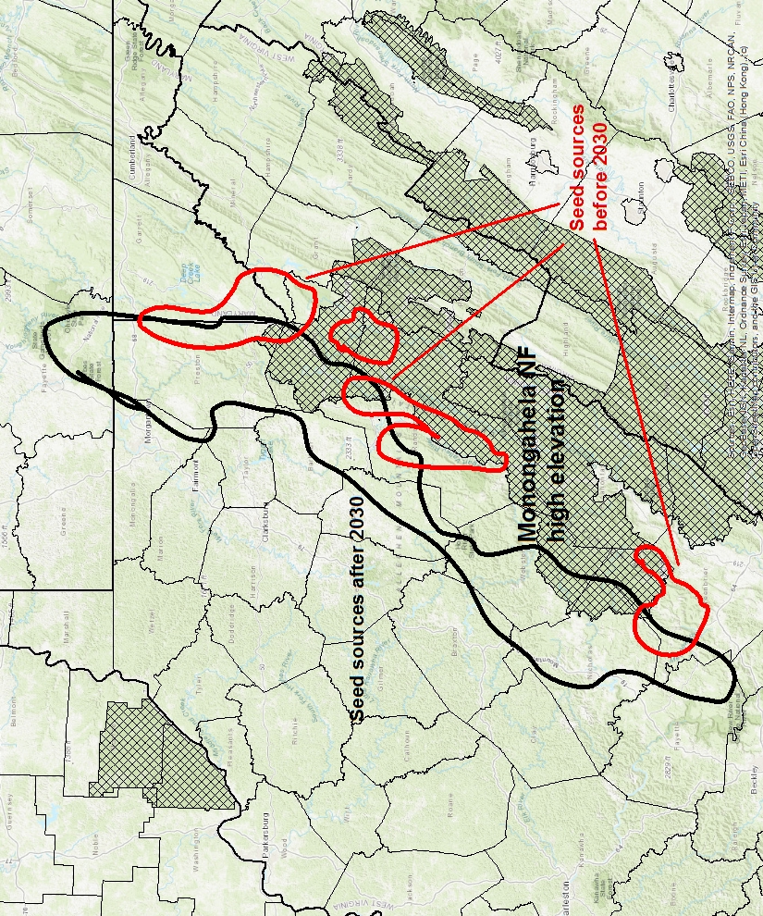
Figure 14 - Seed sources for high elevation areas on the Monongahela NF, now and after 2030.
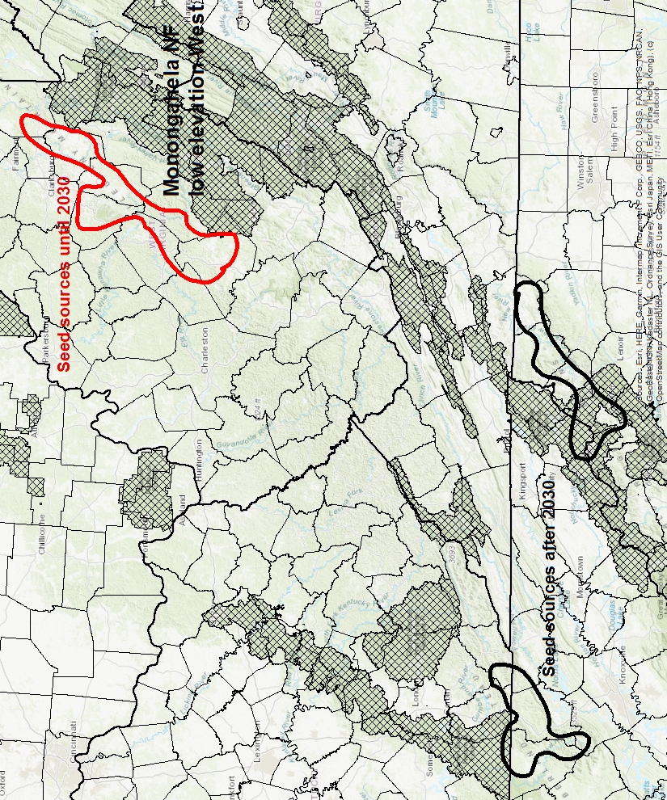
Figure 15 - Seed sources for low elevation areas on the west side of the Monongahela NF, now and after 2030.

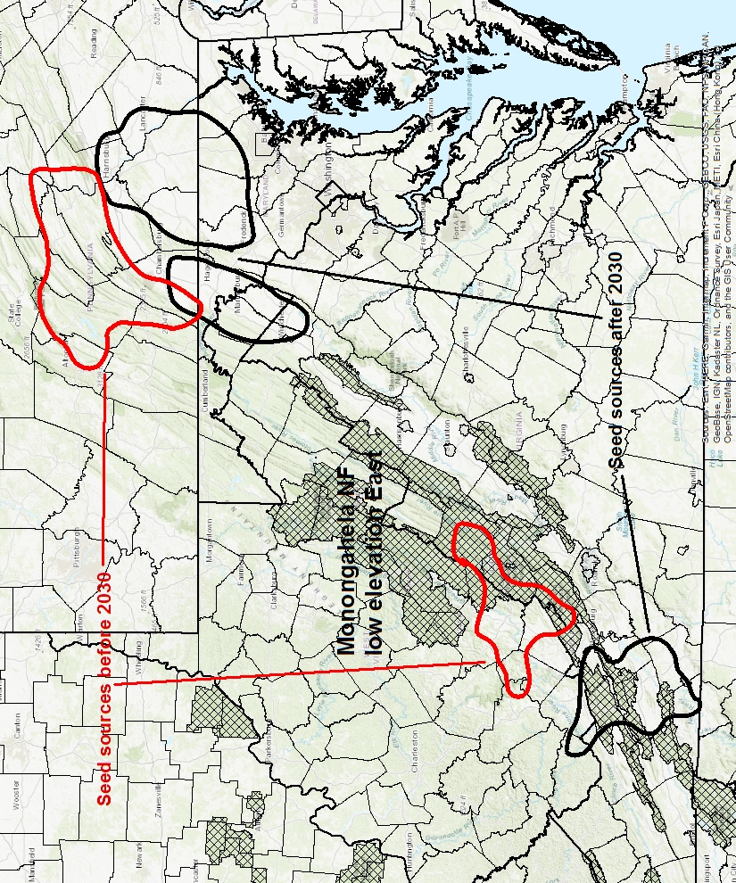
Figure 16 - Seed sources for low elevation areas on the east side of the Monongahela NF, now and after 2030.

Nicolet National Forest

The Nicolet NF is located in northwestern Wisconsin and is the western part of the combined Chequamegon-Nicolet NF. It does not have significant elevational gradients. In the past this unit was divided into northern and southern tree seed collection zones, but the use of the Seedlot Selection Tool suggests that the entire Nicolet NF and a good portion of the Ottawa NF to the north are climatically similar.
The Forest has an active forest management program which includes a fair amount of artificial regeneration.
The most appropriate place to obtain seed now for operational reforestation on the Nicolet NF would be from an area in eastern and central Wisconsin. Starting around 2030, seed collections should shift further south and west to southeastern Wisconsin and nearby parts of northern Illinois (Figure 17).

Ottawa National Forest

The Ottawa NF is located at the western end of the Upper Peninsula of Michigan. It does not have significant elevational gradients although the climate is a little different in parts of the Forest that are close to Lake Superior. The Ottawa NF has an active forest management program that includes a moderate amount of artificial reforestation.
Most of the Ottawa is climatically similar to the Nicolet side of the Chequamegon-Nicolet NF and its seed source recommendations are similar as well. Before 2030 seed for operational reforestation for the Ottawa should from eastern and central Wisconsin. After 2030, seed should be obtained from an area in southeastern Wisconsin and nearby parts of northern Illinois (Figure 18).

Shawnee National Forest

The Shawnee NF is located in southern Illinois. Most regeneration on this forest is natural. Climatic variation within the Forest is limited and the 1970 Tree Seed Collection Zones placed the Shawnee in a single zone along with the Wayne and Hoosier NFs.
Before 2030, most of the climatically appropriate areas to collect seed for the Shawnee are slightly south of the Forest in the Bootheel of Missouri and northeastern Arkansas. After 2030, seed collection should shift somewhat south to include an area in eastern Arkansas (Figure 19).

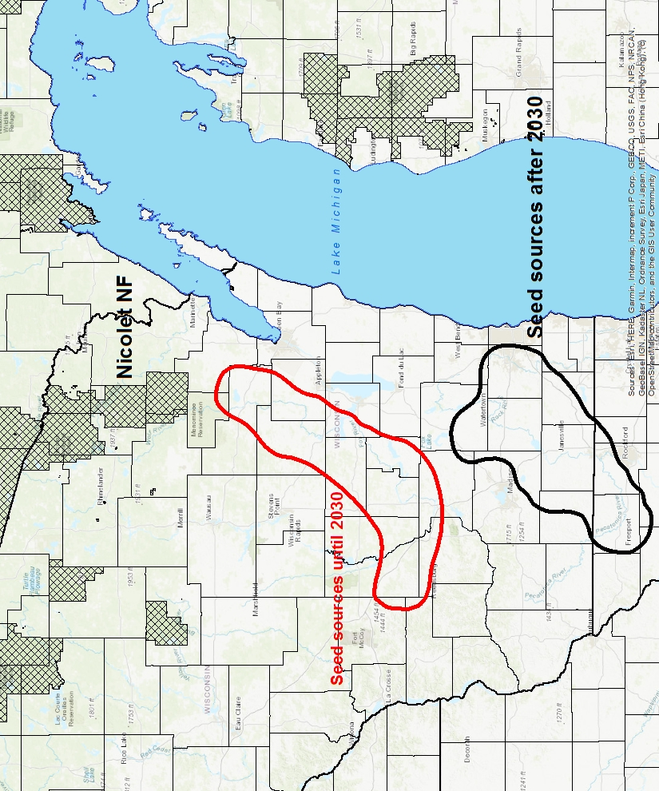
Figure 17 - Seed sources for the Nicolet NF, now and after 2030.

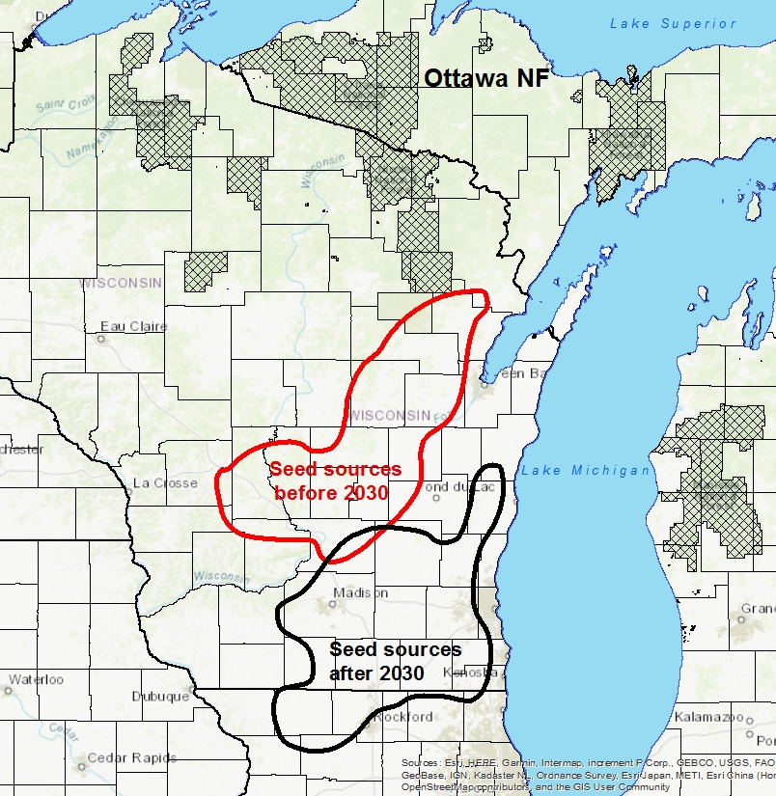
Figure 18 – Seed sources for the Ottawa NF, now and after 2030.

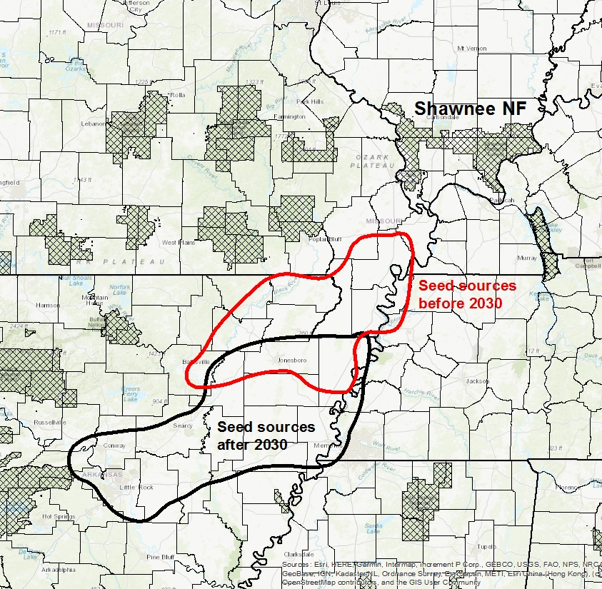
Figure 19 - Seed sources for the Shawnee NF, now and after 2030.

Superior National Forest

The Superior NF is located in northeastern Minnesota. It is a large forest that plants a substantial number of trees. The 1970 Tree Seed Collection Zones divided it into eastern and western portions. While there is some climatic variation along that axis, it probably makes more sense to split zones between the Chippewa NF and the Superior than in the middle of the Superior. From the climatic point of view, a more substantial difference exists between the parts of the Superior NF right along the North Shore of Lake Superior and areas further away from the lake. There will be separate discussions for the Northshore and “Inland” parts of the Forest.
Before 2030, seed for operational planting on the Inland parts of the Superior NF should come from parts of Minnesota to the south of Duluth, MN and nearby parts of northwestern Wisconsin. After 2030, seed for this area should come from slightly further south; west of Minneapolis (Figure 20).
The appropriate areas to collect seed for the Northshore of Lake Superior before 2030 include parts of the western end of the Upper Peninsula and nearby parts of Wisconsin. It should be noted that this includes the area classified as Zone 5 in the 1970 Tree Seed Collection Zones. Depending on the species needed, this seed may already exist in the Region 9 Seed Cache at the J.W. Toumey Nursery. After 2030, the seed for this part of the Superior NF should come from eastern Wisconsin (Figure 21).

Wayne National Forest

The Wayne National Forest is located in southeastern Ohio on the unglaciated portion of the Allegheny Plateau. Although the Forest includes a relatively small number of acres, they are distributed among 3 widely separated pieces. In spite of being spread over a relatively large area, it is not necessary to divide the Forest up into separate zones. The vast majority of the regeneration on the Wayne is natural.
Before 2030, seed for operational reforestation on the Wayne NF should come from certain areas in northern Kentucky. After 2030, seed collection should shift slightly south and west to western Kentucky (Figure 22).

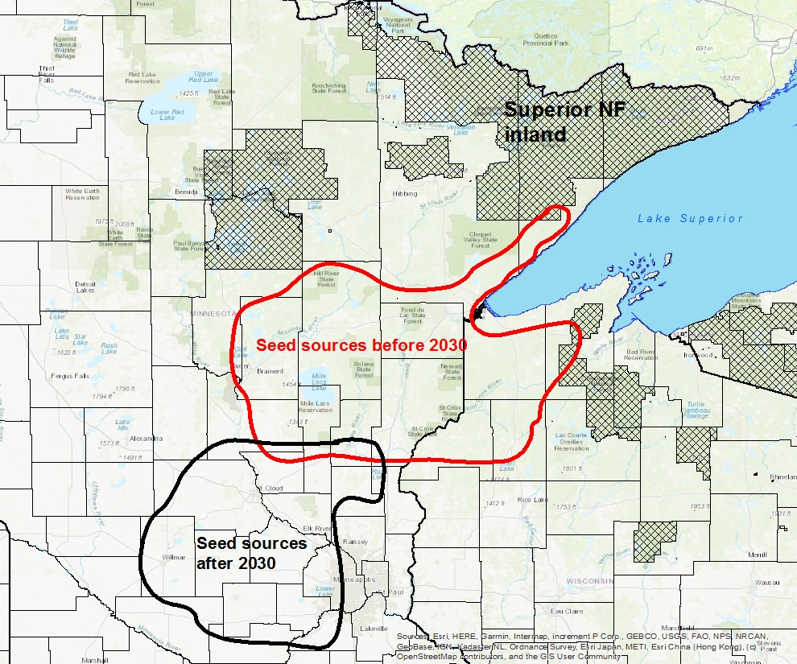
Figure 20 – Seed sources for most of the Superior NF, now and after 2030.

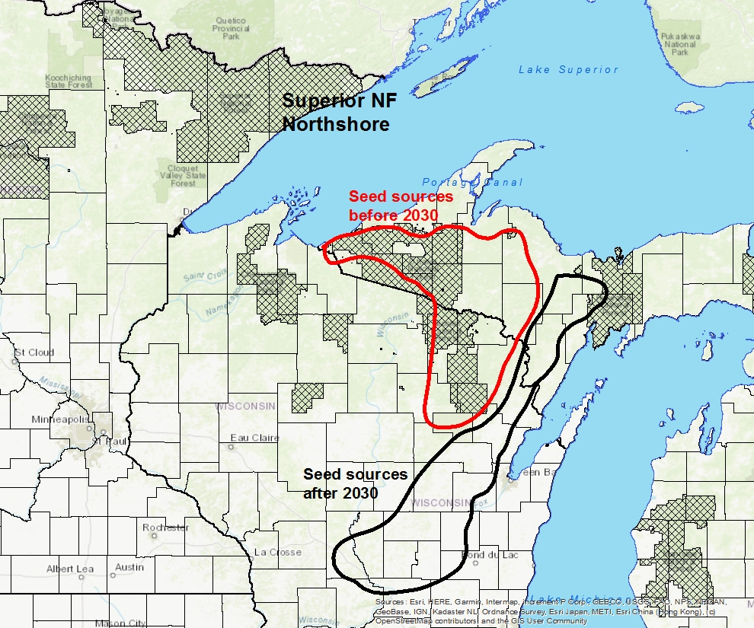
Figure 21 - Seed sources for Northshore portion of the Superior NF, now and after 2030.

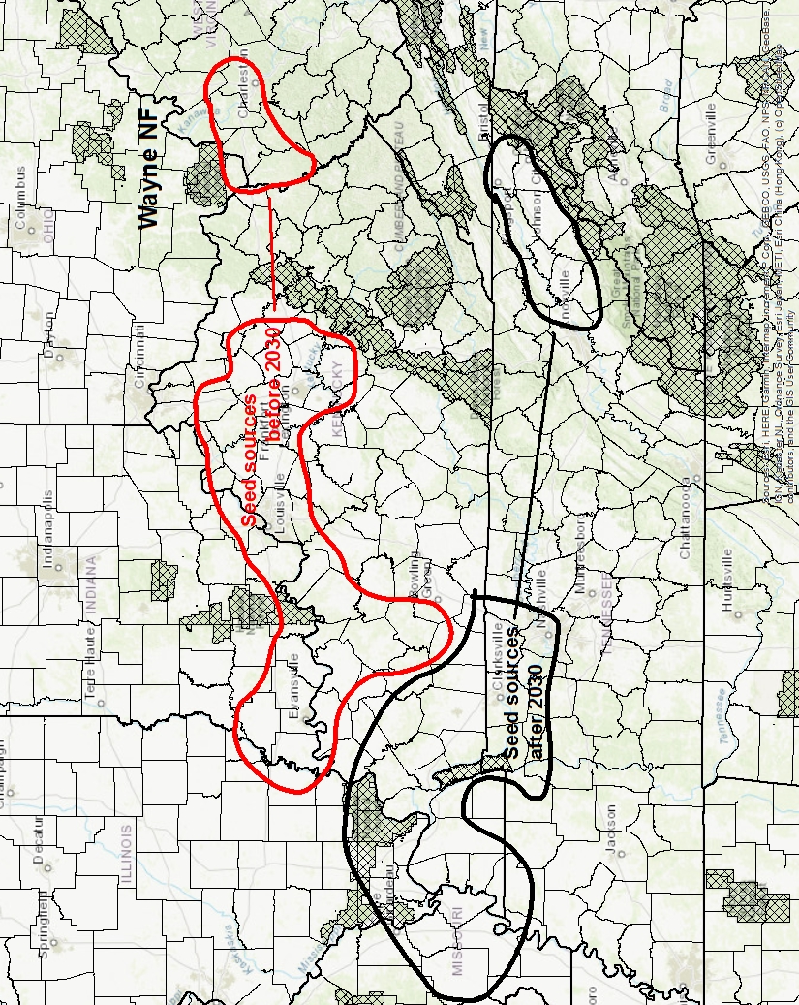
Figure 22 - Seed sources for the Wayne NF, now and after 2030.

White Mountain National Forest

The White Mountain NF is located at the northern end of the Appalachian Mountains in northern New Hampshire. This Forest includes the largest range of elevations of any Region 9 Forest and extends from less than 1,000 feet to more than 6,000. The Forest has an active forest management program, but most of the activity is at lower elevations and tree growth is very limited above 4,000 feet. Almost all of the regeneration on the White Mountain NF is natural, but the forest may elect to plant trees to introduce plant material that will be adapted to future climates. There will be separate discussions for representative planting sites at high elevation (3.500 feet), mid elevation (2,500 feet) and low elevation (1,500 feet). It should be noted that the White Mountain NF includes lands that are substantially higher in elevation than the representative “high elevation” site used in this discussion. These are ignored in this discussion since little tree growth occurs there.
The high elevation areas on the White Mountain NF are an unusual habitat in eastern United States and there are very few areas like it. This suggests there will be very few areas that will be appropriate sources of seed for these sites in the future. Before 2030, there are a few mid elevation areas in the Green Mountains of Vermont that have a climate similar to what is predicted for high elevations on the White Mountain NF. After 2030, the choices are even more limited. The Seedlot Selection Tool predicts that only a small area west of the Monongahela NF will be appropriate for planting at high elevations on the White Mountain. Probably the most important point here is that as climate changes it will become very difficult to acquire seed that is appropriate for planting at high elevations on the White Mountain (Figure 23).
It should not be quite as difficult to find appropriate sources of seed for mid elevation areas on the White Mountain NF. Before 2030 seed for operational reforestation could come from mid elevation areas in the southern Green Mountains, the southern Adirondacks and the Catskill Mountains. After 2030, seed could come from western Massachusetts or from the southern Appalachians just to the west of the Monongahela NF. These recommendations are in widely different locations and it would be wise to re-evaluate these choices when it gets closer to 2030 and to monitor the success of planting from the different sites (Figure 24).
For low elevation areas on the White Mountain, before 2030 seed for operational reforestation should come from western Massachusetts or from an area just to the south of the Adirondacks. After 2030 seed should come from a portion of the Allegheny NF or a portion of the Monongahela NF (Figure 25).

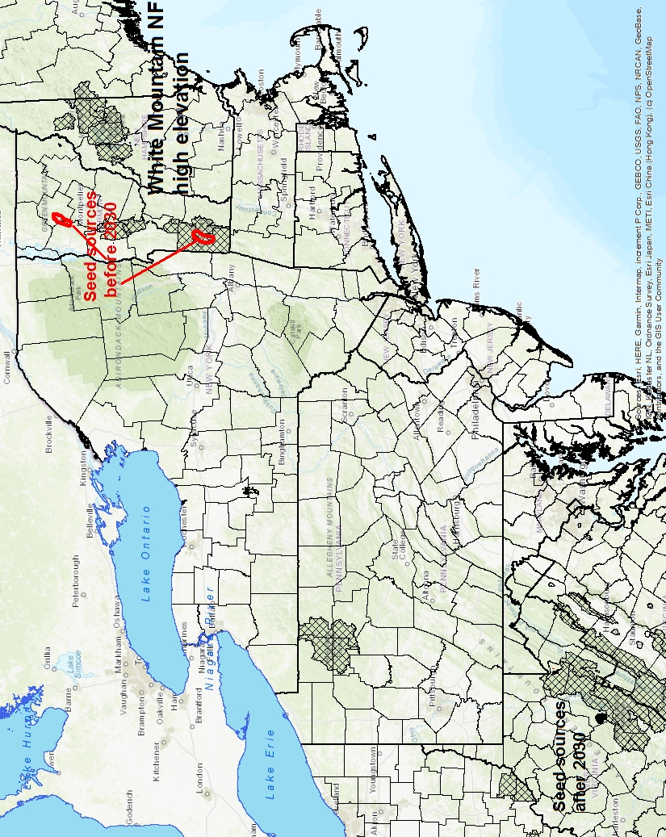
Figure 23 – Seed sources for high elevation planting on the White NF, now and after 2030.

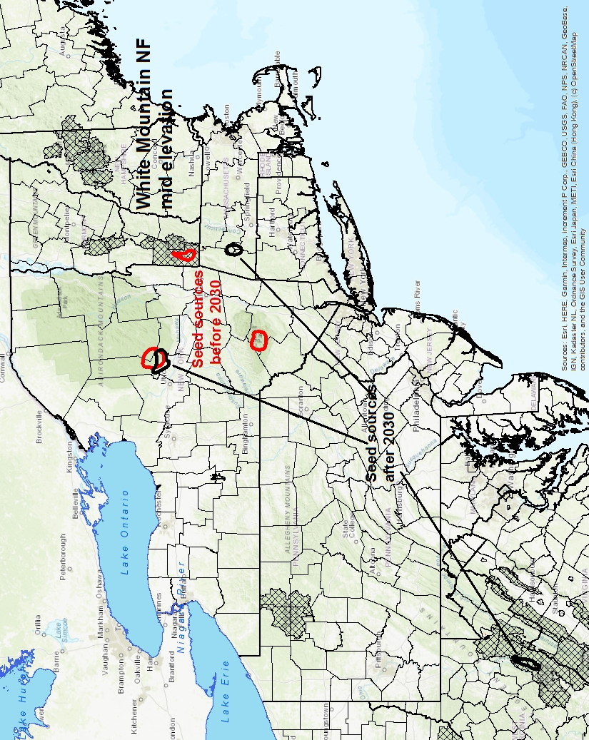
Figure 24 – Seed sources for mid elevation planting on the White NF, now and after 2030

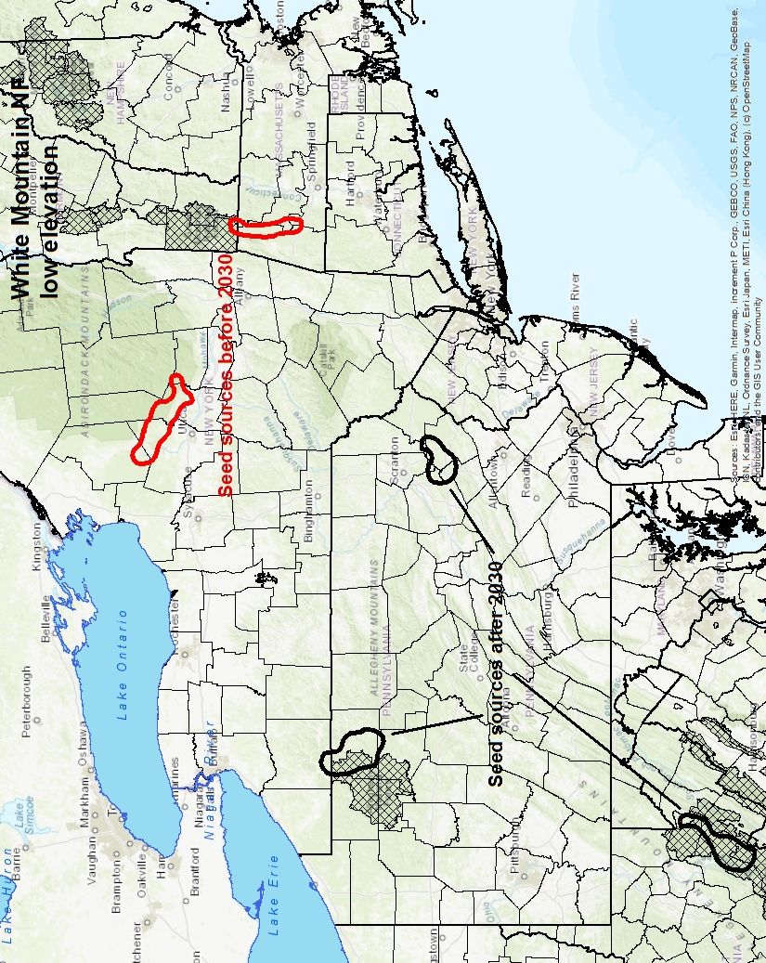
Figure 25 - Seed sources for low elevation planting on the White NF, now and after 2030

References

Clausen, K.E. 1975. Variation in early growth and survival of yellow birch provenances. 22nd NE For. Tree Imp Conf. Aug 7-9, 1974, Syracuse, NY.
Erickson, V., Aubry, C., Berrang, P. Blush, T., Bower, A., Crane, B. DeSpain, T., Gwaze, D., Hamlin, J., Horning, M., Mahalovich, M., Sniezko, R., and St. Clair, B. 2012. Genetic resource management and climate change: Genetic options for adapting National Forests to climate change. Washington DC: USDA Forest Service, Forest Management.
Iverson, L.R., Schwartz, M.W. and Prasad, A.M. 2004. How fast and far might tree species migrate in the eastern United States due to climate change? Global Ecol. Biogeogr. 13:209-219.
Jeffers, R.M. and Jensen R.A.1980. Twenty-year results of the Lake States jack pine seed source study. Res. Pap. NC-181. St. Paul, MN. USDA Forest Service, North Central For. Expt. Stn.
Kriebel, H.B., Bagley, W.T., Deneke, F.J., Funsch, R.W., Roth, P., Jokela J.J., Merritt, C., Wright, J.W. and Williams, R.D.1978. Geographic variation in Quercus rubra in North Central United States plantations. Silvae Genetica 25(3-4)118-122.
Leites, L.P., Rehfeldt, G.E. and Steiner, K.C. 2019. Adaptation to climate in five eastern North America broadleaf deciduous species: Growth clines and evidence of the growth-cold tolerance trade-off. Pers. Plant Ecol. Evol. Syst. 37:64-72.
Liebhold, A.M., McCullough, D.G., Blackburn, L.M., Frankel, S.J., Van Holle, B. and Aukema, J.E. 2013. A highly aggregated geographical distribution of forest pest invasions in the USA. Diversity and Distributions 19: 1208-1216.
Matthews, S.N., Iverson, L.R., Peters, M.P. and Prasad, A.M. 2018. Assessing potential climate change pressures across the conterminous United States: Mapping plant hardiness zones, heat zones, growing degree days, and cumulative drought severity throughout this century RMAP-NRS-9. Newtown Sq., PA. USDA Forest Service, Northern Res. Stn.
Mann, M.E., Zhang, Z., Hughes, M.K., Bradley, R.S., Miller, S.K., Rutherford, S, and Ni, F. 2008. Proxy-based reconstructions of hemispheric and global surface temperature variations over the past two millennia. PNAS 105 (36) 13252-13257.
Neukom, R., Barboza, L.A., Erb, M.P., Shi, F., Emile-Geay, J., Evans, M.N., Franke, J., Kaufman, D.S., Lucke, L, Rehfeld, K., Schurer, A., Zhu, F., Bronnimann, S., Hakim, G.J., Henley, B.J., Ljungqvist, F.C., McKay, N., Valler, V. and von Gunten, L. 2019. Consistent multidecadal variability in global temperature reconstructions and simulations over the Common Era. Nature Geoscience 12:643-649.
Ontario Seed Plant. 2014. Seeds of Ontario Trees and Shrubs: Field Manual for Crop Forecasting and Collecting. Angus, Ontario: Ontario Ministry of Natural Resources.
Parker, W.H. and van Niejenhuis, A. 1996. Regression-based focal point seed zones for Picea marianafrom northwestern Ontario. Can. J. Bot. 74: 1227-1235.
Prasad, A.M., Gardiner, J.D., Iverson, L.R., Matthews, S.D. and Peters, M. 2013. Exploring tree species colonization potentials using a spatially explicit simulation model: implications for four oaks under climate change. Global Ecol. Biogeogr. 19:2196-2208.
Rehfeldt, G.E., Wykoff, W.R. and Ying, C.C.2001. Physiologic plasticity, evolution, and impacts of a changing climate on Pinus contorta. Climate Change 50: 355-376.
St. Clair, B. and Howe, G. 2009. Genetic options for adapting forests to climate change. Western Forests Jan/Feb.
USDA Forest Service. 2008. The Woody Plant Seed Manual. Agric. Hdbk. No. 727. F.T. Bonner and R.P. Karrfalt (eds.). Washington DC: USDA Forest Service. Also available on-line: online version of reference available at website hosted by National Seed Lab of USDA Forest Service
Walter, R. and Epperson, B.K. 2001. Geographic pattern of genetic variation in Pinus resinosa: area of greatest diversity is not the origin of postglacial populations. Mol. Ecol. 10: 103-111.

