Breakout Group Worksheet
San Bernardino Mountains Climate-Informed Vegetation Management

More resouces and information:
Climate Change Response Framework: www.forestadaptation.org and www.adaptationworkbook.org
Workshop site: forestadaptation.org/learn/san-bernardino-mountains-climate-informed-vegetation-management-planning
Climate Change Resource Center: www.fs.usda.gov/ccrc

Adaptation Process:
In this session, we’ll go through an abbreviated version of the adaptation workbook process that is described in Chapter 5 (pp. 74-89) of Forest Adaptation Resources: Climate Change Tools and Approaches for Land Managers, 2nd Edition (Swanston and others, 2016: www.nrs.fs.fed.us/pubs/52760). An online version of the workbook is available at www.adaptationworkbook.org.

1. DEFINE management objectives
2. ASSESS climate impacts
3. EVALUATE management objectives.
4. IDENTIFY adaptation tactics.
5. MONITOR and evaluate effectiveness.

Step 1. Where are you and what do you care about?

Breakout group: _______________________________________

Describe your project area. Tell us more about the following -

Location:
Describe and locate on map below.

Site conditions/current management:

Species composition:
Social considerations/value:
Management goals and objectives:
Goals are general statements that can address a desired state you’d like to achieve (e.g. improve habitat for X species; regenerate a diverse mix of native tree species following a disturbance).
Objectives describe the specific changes you’d like to make to achieve your goals; please make these measurable if possible! (e.g. convert 150 acres of upland to native grassland habitat; plant X density of conifer seedlings in areas where natural conifer regeneration is low).

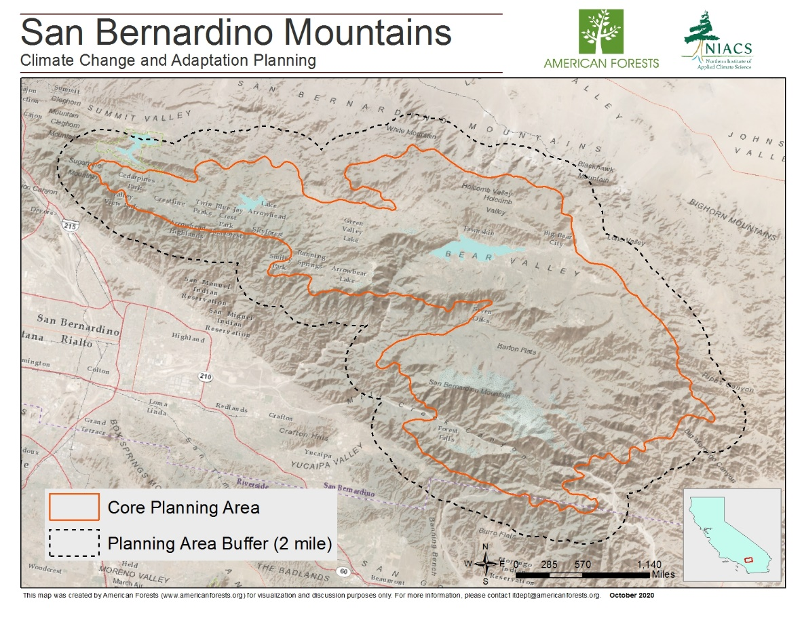

Step 2. How is your project site vulnerable to climate change?
We will discuss this as a full group, but feel free to make notes here. Highlight the top 3 general impacts that will be most important in your specific project area. Include a few notes on how these impacts will influence your site.
Regional impacts | Notes on your site
- Increased average temperatures
- More days with extreme heat
- Fewer days with extreme cold
- More prolonged drought
- More variable precipitation (extreme wet/extreme dry years)
- Decrease in peak snowpack
- Increase in frequent/severe wildfire
- Shifts in habitat suitability for species upslope
- Increase in tree mortality at higher elevations
- Increased habitat suitability for grasslands (relative to shrubs/conifers).
- Other?

Step 3. What challenges or opportunities does climate change present?
Provide more information on how climate change will affect your management objectives for this project site.

Challenges | Opportunities

Feasibility?

Step 4. What actions can help your site adapt to change?
Look at the menu of Adaptation Strategies and Approaches (summaries available at end of document, full versions sent by email). What are some ways to incorporate climate change adaptation into your management?

Menu | Approach | Tactic

Consider:
- Actions that are things you already do that also have benefits for climate adaptation
- Actions that include small tweaks or enhancements to increase the chance for success
- Wild and crazy ideas, or major changes from the current way of doing things

Notes (barriers, co-benefits, limitations):

Report out will include:
- Brief reminder of project area/overall management goals;
- Climate challenges and/or opportunities
- Selected adaptation tactics
- If desired: where else on the landscape might you implement these ideas?

Use the map below to consider:
- In addition to your project area, where might you want to implement some of your selected actions? In what forest types or at what elevations?
- Are there areas of the landscape that are better for more ‘resistance’, ‘resilience’ or ‘transition’ activities?
- List of other types of areas?

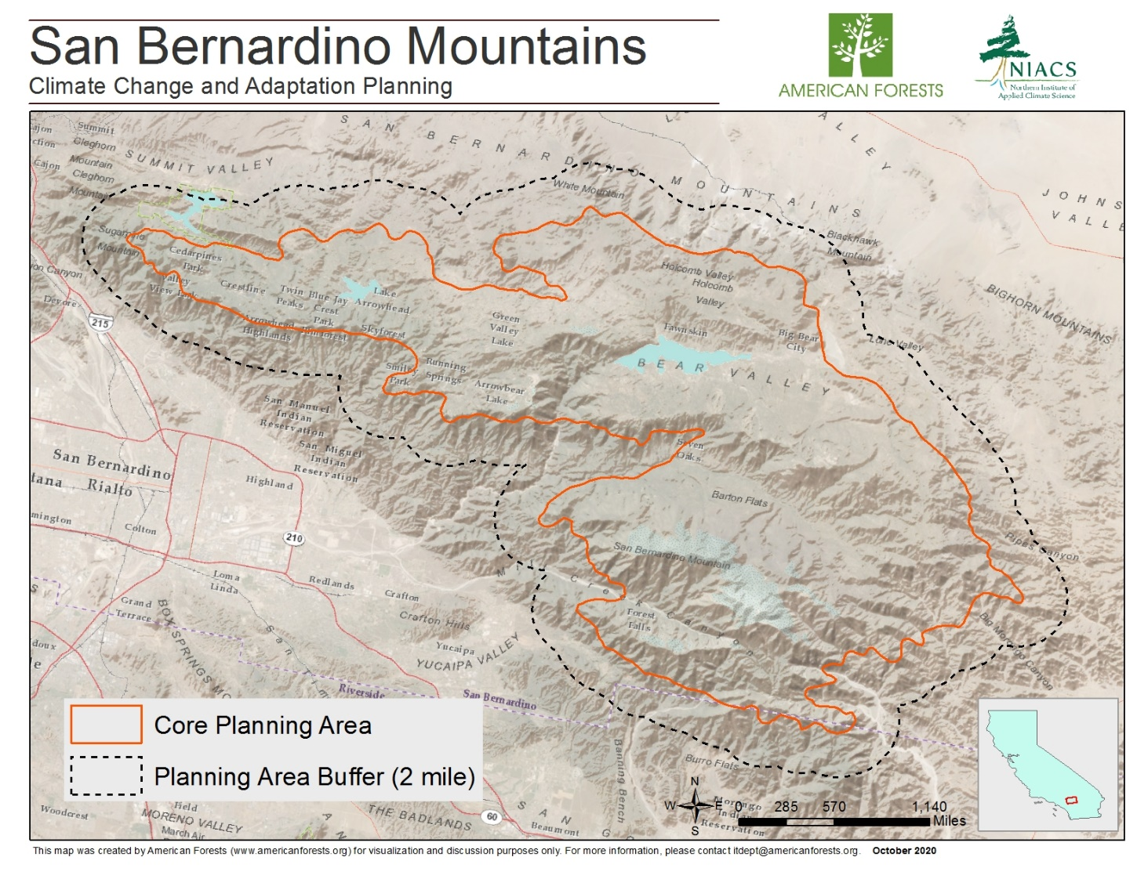

5. How can you know whether your actions were effective?
What is an example of something you could monitor to evaluate whether your management actions helped to both achieve the management goals and increase the forest’s ability to adapt to changing conditions? If needed, use the ‘resilience pillars’ document to think about measurable metrics.

Menu of Adaptation Strategies and Approaches for California Forest Ecosystems
Strategy 1: Sustain fundamental ecological functions.
1.1. Reduce impacts to soils and nutrient cycling.
1.2. Maintain or restore hydrology.
1.3. Maintain or restore functional riparian systems.
1.4. Reduce competition for moisture, nutrients, and light.
1.5. Restore or maintain fire in fire-adapted ecosystems.
Strategy 2: Reduce the impact of biological stressors.
2.1. Maintain or improve the ability of forests to resist pathogens and insect pests.
2.2. Minimize the risk of the introduction and establishment of invasive plants and remove existing invasive species.
2.3. Manage herbivory to promote regeneration of desired species.
Strategy 3: Reduce the risk and long-term impacts of severe disturbances.
3.1. Alter forest structure and/or composition to reduce risk or severity of wildfire.
3.2. Establish and maintain fuelbreaks to minimize the risk of uncharacteristic, high-severity fire.
3.3. Alter forest structure to reduce severity or extent of extreme weather events.
3.4. Promptly revegetate after disturbance.
Strategy 4: Maintain or create refugia.
4.1. Prioritize and maintain unique sites.
4.2. Prioritize and maintain sensitive or at-risk species or communities.
4.3. Establish artificial reserves for at-risk and displaced species.
Strategy 5: Maintain and enhance species and forest structural heterogeneity.
5.1. Promote forest age-, size-class diversity and spatial heterogeneity.
5.2. Maintain and restore diversity of native species.
5.3. Retain biological legacies.
5.4. Establish reserves to maintain ecosystem diversity.
Strategy 6: Maintain or increase ecosystem redundancy across the landscape.
6.1. Manage habitats over a range of sites and conditions.
6.2. Expand the boundaries of reserves to increase diversity.
Strategy 7: Promote landscape connectivity.
7.1. Reduce landscape fragmentation.
7.2. Maintain and create habitat corridors through reforestation or restoration.
Strategy 8: Maintain and enhance genetic diversity.
8.1. Use seeds, germplasm, and other genetic material from across a greater geographic range.
8.2. Favor existing genotypes that are better adapted to future conditions.
Strategy 9: Facilitate community adjustments through species transitions.
9.1. Favor or restore native species that are expected to be adapted to future conditions.
9.2. Establish or encourage new mixes of native species.
9.3. Guide changes in species composition at early stages of forest development.
9.4. Protect future-adapted seedlings and saplings.
9.5. Disfavor species that are distinctly maladapted.
9.6. Manage for species and genotypes with wide moisture and temperature tolerances.
9.7. Introduce species that are expected to be adapted to future conditions.
9.8. Move at-risk species to locations that are expected to provide sustainable habitat.
Strategy 10: Realign ecosystems after disturbance.
10.1 Promptly revegetate sites after disturbance.
10.2. Allow for areas of natural regeneration to test for future-adapted species.
10.3. Realign significantly disrupted ecosystems to meet expected future conditions.

Source: [DRAFT]. Swanston, C.W.; Janowiak, M.K., Brandt, L.A.; Butler-Leopold, P.R.; Handler, S.D.; Shannon, P.D.; Hall, K.; Schmitt, K.M.; Meyer, M.; Molinari, N.; Merriam, K.; Wuenschel, A.; Smith, J.B.; Ostoja, S.M 2020. Adaptation Strategies and Approaches for California Forest Ecosystems. USDA California Climate Hub Technical Report CACH-12020-1. Davis, CA: U.S. Department of Agriculture, Climate Hubs. In preparation.

Fire-Climate Adaptation Strategies and Approaches
Strategy 1: Sustain fire as a fundamental ecological process
1.1. Restore or maintain fire in fire-adapted ecosystems.
1.2. Develop fire use strategies in altered or novel ecosystems where fire can play a beneficial role.
1.3. Protect fire-sensitive ecosystems from fire.
Strategy 2: Reduce the effects of biotic and abiotic stressors on fire regimes.
2.1. Prevent the establishment and spread of nonnative invasive species, and remove existing populations.
2.2. Maintain or improve the ability of forests to resist pests and pathogens.
2.3. Limit and selectively apply land uses that alter or degrade ecosystem structure and/or function.
Strategy 3: Reduce the risk of unacceptably severe fire.
3.1. Alter forest structure and/or composition to reduce the risk of unacceptably severe wildfire.
3.2. Establish fuel breaks to stop the spread of unacceptable wildfire.
Strategy 4: Promote post-fire recovery.
4.1. Maintain or create refugia.
4.2. Facilitate post-fire ecosystem recovery to reduce the long-term effects of unacceptable wildfire.
4.3. Promote habitat connectivity and increase ecosystem redundancy at the landscape scale.
Strategy 5: Maintain and enhance structural, species and community diversity.
5.1. Promote diversity within and among communities.
5.2. Maintain or increase structural diversity at the landscape scale.
5.3. Maintain or restore diversity of native tree and understory plant species.
Strategy 6: Maintain and enhance genetic diversity to promote fire resilient genotypes.
6.1. Use seeds, germplasm, and other genetic material from across a greater geographic range.
6.2. Favor existing genotypes that are better adapted to future conditions.
6.3. Increase seed banking efforts to preserve genetic diversity.
Strategy 7: Facilitate ecosystem adaptation to expected future climate and fire regimes.
7.1. Promote native species that are expected to be resilient to future climate and fire regimes and disfavor species that are distinctly maladapted.
7.2. Facilitate the movement of species that are expected to be adapted to future conditions and fire regimes.
7.3. Consider using fire as a tool to align existing vegetation communities with changing climate regimes.
Strategy 8: Use fire events as opportunities for ecosystem realignment.
8.1. Revegetate burned areas using fire-tolerant and drought-adapted species and genotypes.
8.2. Allow for areas of natural regeneration to test for future-adapted species.
8.3. Realign ecosystems that have undergone post-fire vegetation type conversion to meet expected future conditions.
Strategy 9: Promote organizational and operational flexibility.
9.1. Develop adaptive staffing and budgeting strategies.
9.2. Explicitly consider future and changing ecological conditions during the planning process and adaptive management cycle.
9.3. Facilitate and streamline information management and sharing.
Strategy 10: Promote fire-adapted human communities.
10.1 Increase fuel reduction treatments in the wildland-urban interface.
10.2. Actively promote broad social awareness and Increase education and about anticipated effects of climate change on local fire regimes at all scales.

Source: [DRAFT]. Fire-Climate Adaptation Strategies and Approaches: https://swfireclime.org/fire-climate-adaptation-tools/.
Thode et al. 2020. SW FireCLIME: Landscape Impacts of Fire and Climate Change in the Southwest. Final Report. JFSP Project ID 15-1-03-26

