Integrating Climate Change into Management Plans
Adaptation Workbook Process
Described in Forest Adaptation Resources: Climate change tools and approaches for land managers, 2nd edition (www.nrs.fs.fed.us/pubs/52760) and also available as an online tool at www.adaptationworkbook.org.
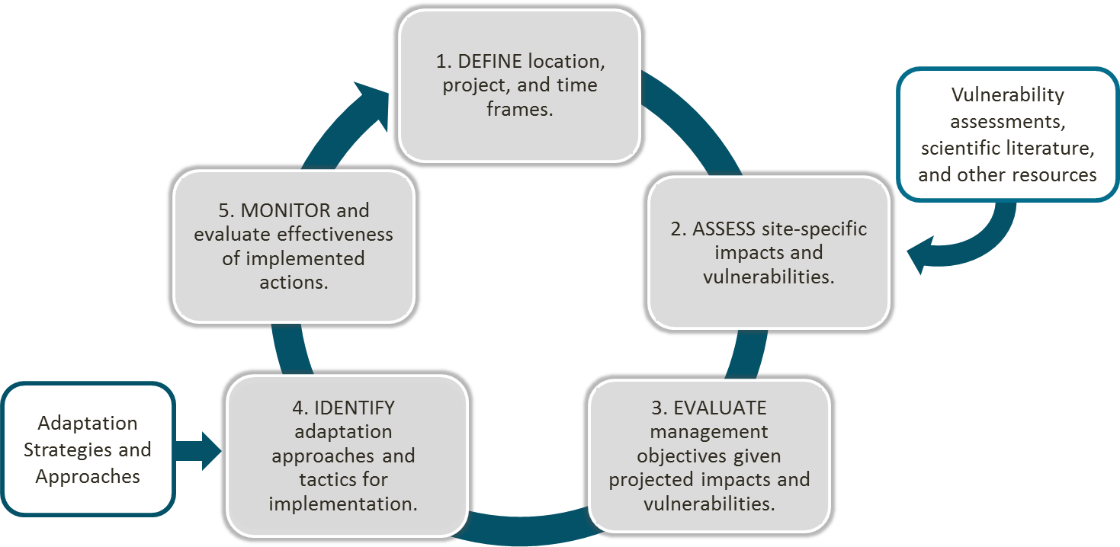

Step 1: DEFINE location, project, and time frames.
What are your management goals and objectives for the project area?
Project Area
& Location:
Management Goals |  | Management Objectives

Step 2: ASSESS site-specific climate change impacts and vulnerabilities.
What climate change impacts and vulnerabilities are most important to this particular site?
- Select the climate change impacts that are most likely to affect your project.
Which of these regional climate change impacts is likely to affect your area? | How could these regional climate change impacts affect your local area? Which present the greatest risk, and why?
- Warmer annual & seasonal temperatures
- More days with extreme heat
- Fewer days with extreme cold
- Shorter, warmer winters
- Longer growing season
- Increased winter and spring precipitation
- More frequent heavy precipitation events
- Decrease (slight or large) in summer precipitation
- Reduced soil moisture in summer
- More high streamflow days in winter and spring
- More low streamflow days in the summer and fall
- Declines in northern plant and animal species
- Increases in southern plant and animal species
- Increased risk of wildfire
- More damage from insect pests & forest pathogens
- Increases in nonnative plant species
- Other:
- How vulnerable is your project area to climate change?
Vulnerability Ratings (pick one per time period) | Nearer term  (10-30 years) | Long term  (50+ years)
Low – Ecosystems are expected to readily cope with potential climate change impacts. Climate change is more beneficial to ecosystems than disruptive.
Moderate – Climate change impacts are expected to alter ecosystems, but ecosystems will be able to cope with some impacts.
High – Climate change impacts are expected to exceed the ability of the ecosystem to cope with impacts. Ecosystems may undergo changes that will disrupt important ecosystem functions and key environmental benefits.
Step 3: EVALUATE management objectives given projected impacts and vulnerabilities.
What management challenges and opportunities may occur as a result of climate change?
Based on the risks from climate change over the next 20-50 years, do you have confidence that your current management objectives will be successful using current (business-as-usual) management actions? Identify whether your objectives have high, medium, or low feasibility.
- High: We can do it! Opportunities > Challenges
- Low: We’ll need more resources or effort. Challenges > Opportunities

Greatest Management Challenges  from Climate Change | Greatest Management Opportunities from Climate Change

The Northern Institute of Applied Science has led the development of Adaptation Strategies and Approaches for various natural resource topics, which can be used with the Adaptation Workbook. These “menus” provide topical lists of adaptation actions that not only help you move from broad ideas to specific actions and express the adaptation intent of your actions. Although menu items can be applied in various combinations to achieve desired outcomes, not all items on the menu will work together or work in every ecosystem. Land managers can use these menus to select appropriate actions based on their unique project location and goals.

- Forest Ecosystems
- Urban Forests
- Forested Watersheds
- Agriculture
- Tribal Perspectives
- Forest Carbon
- Recreation
- Non-Forested Wetlands

Also in development: wildlife management, ocean coastal ecosystems, Great Lakes coastal ecosystems, grasslands.

Step 4: IDENTIFY adaptation approaches and tactics for implementation.
What actions can enhance the ability of the area to adapt to anticipated changes and meet management goals?
Look at the menus of Adaptation Strategies and Approaches. What are some ways to incorporate climate change adaptation into your management? (Label your ideas with the menu and the Strategy/Approach numbers)
- Management actions that are already part of the plan that also have benefits for climate adaptation:

- Small tweaks or enhancements to management actions that will increase the chance for success:

- Wild and crazy ideas, or major changes to the management actions:

Step 5: MONITOR and evaluate effectiveness of implemented actions.
What is an example of something you could monitor to evaluate whether your management actions helped to both achieve the management goals and increase the forest’s ability to adapt to changing conditions?

